
Level 3 Applied Science: Medical Science
Bridging Work 2026

Head of Department: Vocational: Miss N. Kenny nkenny@carshaltongirls.org.uk
Biology: Mr. A. Kart: akart@carshaltongirls.org.uk

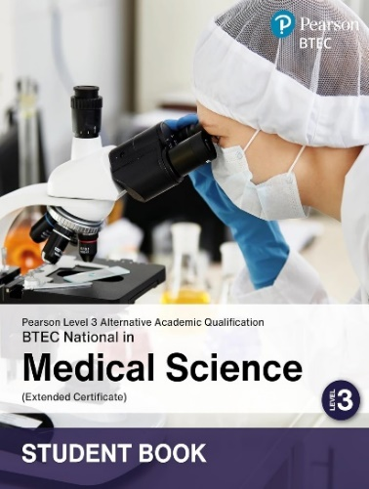
ISBN-10: 1292487097
https://qualifications.pearson.com/en/qualifications/btec-nationals/medical-science-aaq.html
Structure of the Course
The course will be taught between the Science and Vocational departments, with practical elements delivered in laboratories.
Mandatory
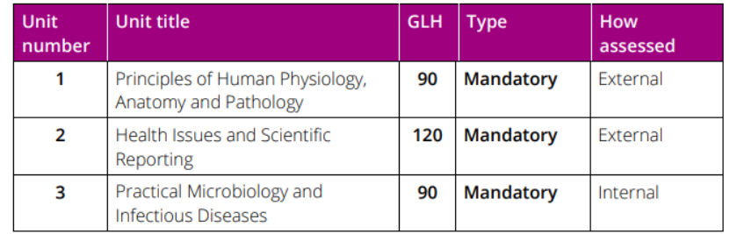
Optional

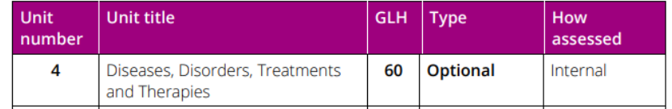

YEAR 12
UNIT 1 Exam in May 2027 (Resit opportunity in January 2028)
UNIT 2 Exam in May 2027 (Resit opportunity in January 2028)

YEAR 13
UNIT 3 Internal Assessment
UNIT 4 Internal Assessment

SUMMER WORK

This work should be brought to your first lesson in September.
THE HEART 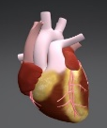
TASK 1
Watch this video.
https://www.youtube.com/watch?v=mDHXIky7Krc
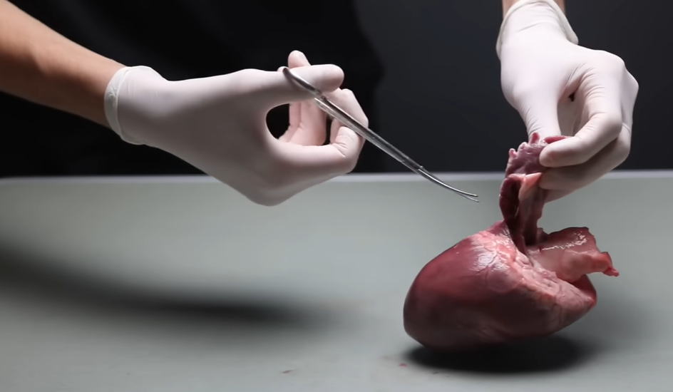
TASK 2
Complete an A3 sized poster of the heart. Include a diagram of the heart with its component parts labelled. Include a section which briefly describes the function of each part.
TASK 3
Heart muscle is myogenic, this means it can beat by itself without an external stimulus. Watch the following two videos and record your answers to the questions below in writing. You may need to carry out further research. Record any sources you use at the end of your writing.

- 01 7 Beating Heart Cell - YouTube - Single heart cell beating
- https://www.youtube.com/watch?v=BqzW9Jq-OVA – Heart muscle cells under a microscope

Q1: Why is it important for heart cells to contract synchronously?
Q2: How many beats per minute are the cells in the first 30 seconds of the second video.
Q3: How are the cells of the heart coordinated?

TASK 4
Heart and Health
There are a number of risk factors that can increase your chances of developing Coronary Heart Disease earlier in life; these are explored in a BBC article (Heart deaths up for first time in 50 years - BBC News) and the following links:

- Smoking
- Obesity
- Blood Cholesterol level
- Diabetes
- Family History

Produce brief notes on each risk factor. Family history is completed for you as an example:

- Family History- Genes inherited from your parents can increase the risk of CHD, where you either have inherited high blood pressure or high cholesterol. Family History can be referred to as “non-modifiable” risk factor, as you can’t have any impact on changing it.

CHALLENGE
Listen to this podcast, or read the published paper. Write a brief reflection.
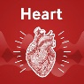 https://www.podbean.com/ep/pb-rshdu-1aeb5e2

Professor Carel le Roux In this episode of the Heart podcast, Digital Media Editor, Professor James Rudd, is joined by Professor Carel le Roux from University College, Dublin and Ulster University. They discuss the trial evidence that has emerged over the last 20 years for both bariatric surgery and the newer GLP-1 medications, focusing particularly on reductions in cardiovascular outcomes. They also discuss where the field of obesity intervention might head over the next five years and how metabolic surgery will continue to have an important role. Read the published paper in Heart. Release date: 16th June 2026.

 NON-COMPULSORY BEDTIME LISTENING
If you want some relaxing bedtime listening over the summer, try this…
https://www.youtube.com/watch?v=CfvYbXUma5U
It will help you sleep and might give your anatomy and physiology knowledge a boost!

See you in September!


