
Early Childhood Development Year 12 Bridging Work

Course Leader: Miss N. Kenny nkenny@carshaltongirls.org.uk

BTEC Nationals

Early Childhood Development (AAQ) Extended Certificate

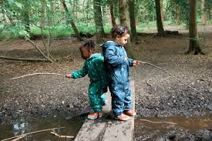
In preparation for your course, we would like you to complete two tasks and to bring this work in with you in September.
Task 1
Produce an A4 poster on how the brain develops from conception through childhood, to adulthood. In this, you must consider the role of neurons, and you must give a detailed explanation of how neurons work. Use diagrams to support your explanation. Include your sources.
Task 2
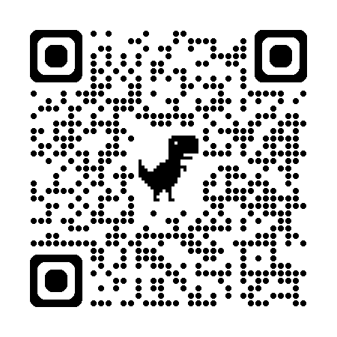
Scan the QR Code. https://www.bbc.co.uk/news/articles/cx2ev5j47xlo
Read the article. Answer the three questions. Type your responses or write your answers on lined paper.
- Research shows that play opportunities are crucial for children to develop. What kind of play opportunities were children not able to experience during the pandemic?
- How does play help to aid the development of children?
- What could have been done during the pandemic to reduce the effects of the restrictions on children’s development?

Units:
The qualification has four units, all of which are mandatory, covering the following topics:
- Children’s Development – Externally examined
- Keeping Children Safe – Externally examined
- Play and Learning – Internally assessed
- Research and Reflective Practice in an Early Childhood Setting – Internally assessed.

We expect you to arrange to spend 50 hours in a work placement with children from 0-8 during your study periods and/ or during your Year 12 Work Experience Week.

The Course
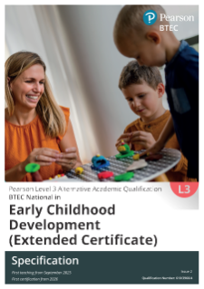 Link to Specification: Early Childhood Development (AAQ) | Pearson qualifications
Text Book
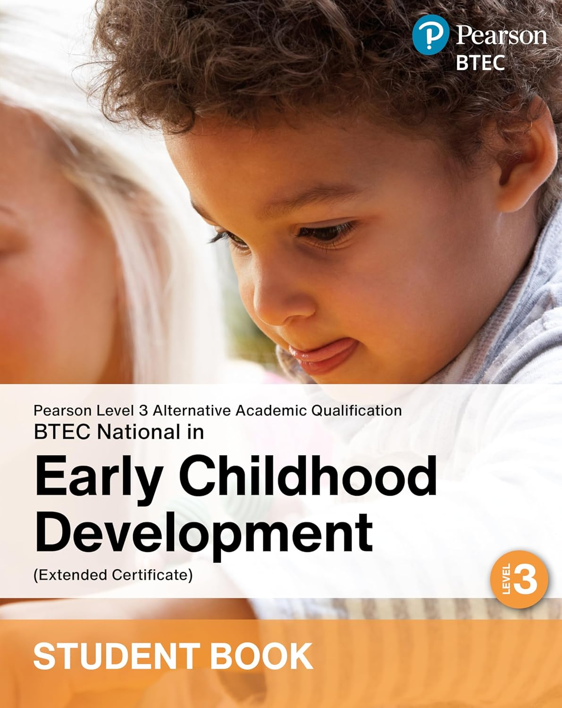
This is the authorised text book: ISBN: 9781292487076
Tutor2U have produced a range of excellent resources which are tailored to the course and are available from their website: https://www.tutor2u.net. There are unit- based knowledge books available which are highly recommended.
Resources
Please equip yourself with lined paper, a strong lever arch file, some plastic pockets, a mini white board and pens.

