**Carshalton High School for Girls –**

Get Ready for Film Studies **December Edition - Animation**

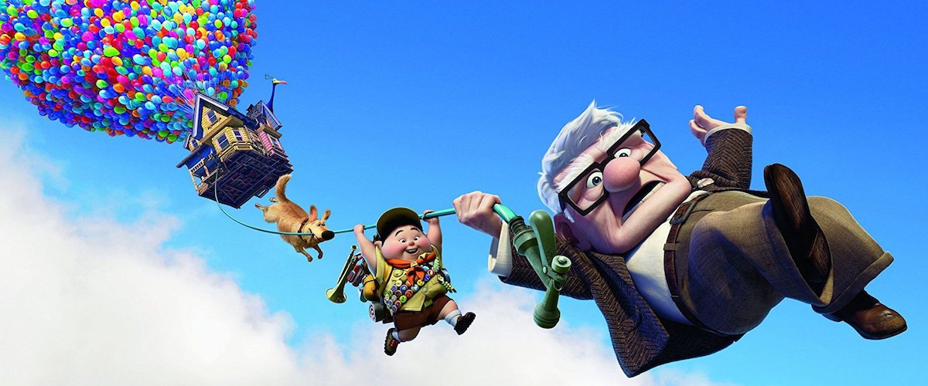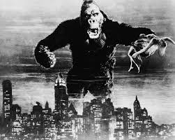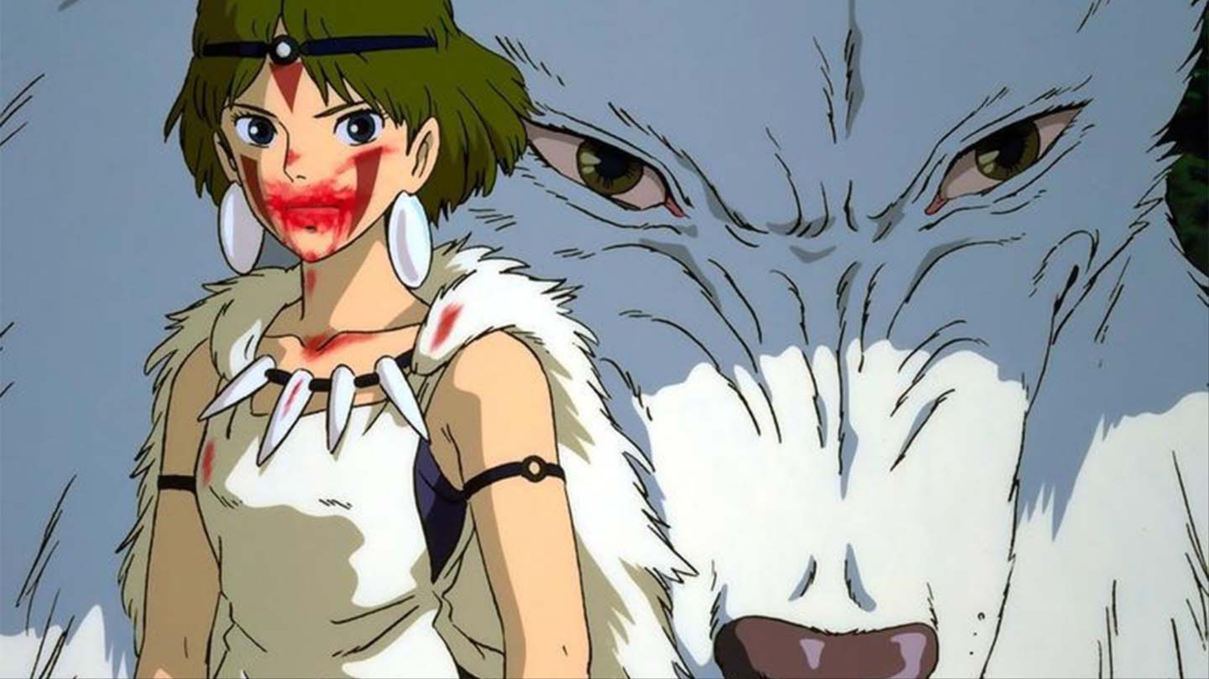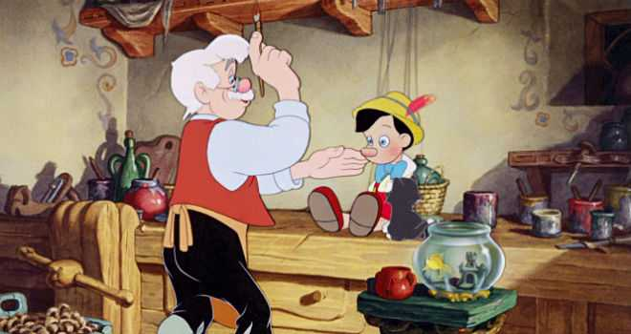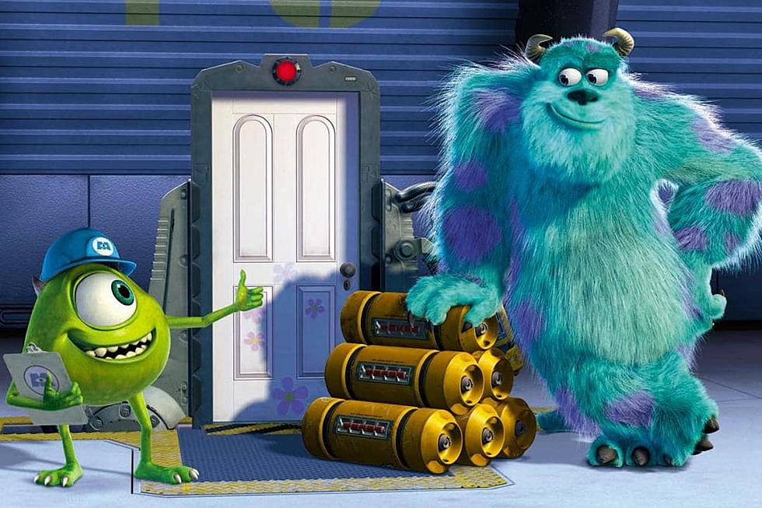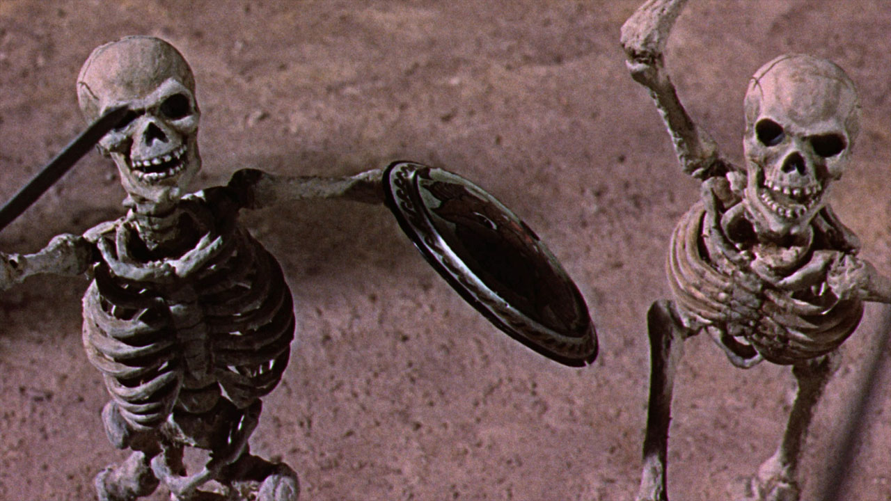

Welcome to the first of a monthly series of newsletters to prepare you for A Level Film Studies at Carshalton High School for Girls. Each newsletter will introduce you to a different film genre, film movement or period of film history and provide you with other tips on what to do to find out about the wonderful world of film. We very much hope you join us in September, although receiving these newsletters obviously doesn’t oblige you to do so! Nor are the newsletters “homework”, you don’t *have* to do any of the things we recommend or watch any of the films we suggest. We just hope you find them interesting, that they help you learn a little bit about film history and that they get you ready in some way for studying a really interesting and engaging A Level.

**Animation**

It’s getting close to Christmas and this month it seems like a good time to look at animation. Alongside watching seasonal classics like *Elf* over the break you might want to watch some of the animated films we recommend.

**Pixar:**

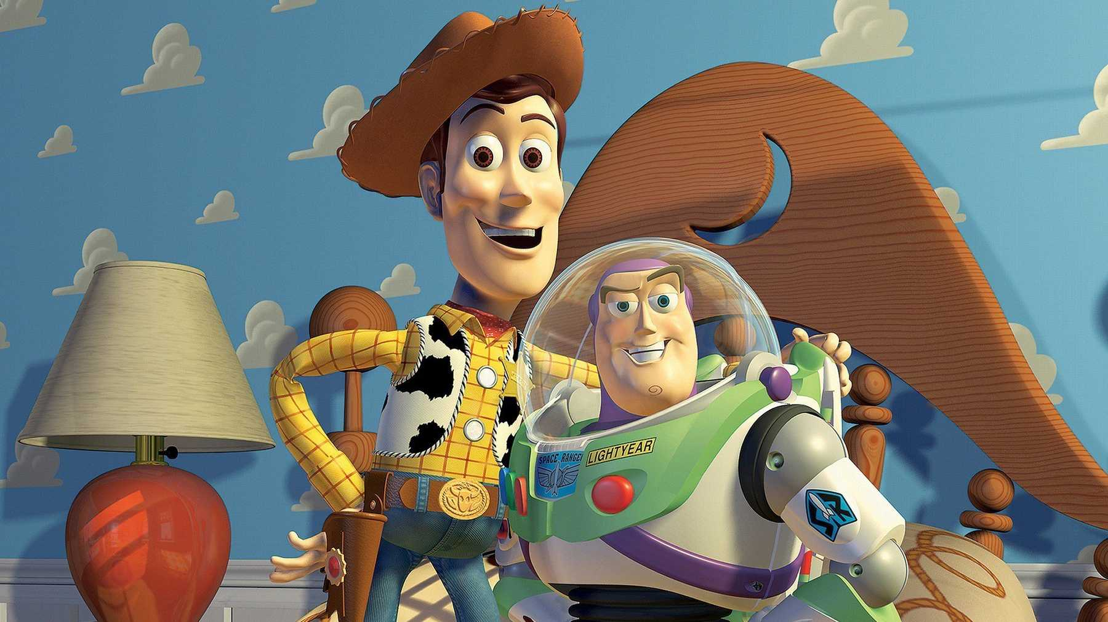You might not realise it but we’re actually living through a golden age of animation. Digital technology has made producing animated films far easier and enabled animators to push boundaries further and further. From the early 1990s onwards animated TV series such as *The Simpsons* demonstrated that there was a demand for clever animation that appealed to adults as much as children. However, it was with the emergence of Pixar in the mid 1990s that modern animated filmmaking really took off. The studio, founded by Steve Jobs – the man who also brought us Apple and the iPhone, pioneered computer aided animation technology to bring audiences a new wave of highly ambitious, innovative animated films. You’ll be very familiar with nearly all of them. Make no mistake, films like *Toy Story* (all four of them), *Up* or *The Incredibles* aren’t just great children’s films or great animated films, arguably they’re some of the best films produced over the last 25 years or so full stop. I saw a lot of films at the cinema last year for example but *Toy Story 4* was quite possibly my favourite – I think I liked it better than Best Picture winner at the 2020 Oscars – *Parasite*. Read more about Pixar on the BFI website here:

<https://www2.bfi.org.uk/news-opinion/news-bfi/features/where-begin-pixar#:~:text=The%20best%20place%20to%20start,the%20door%20to%20their%20genius>.

**Studio Ghibli:**

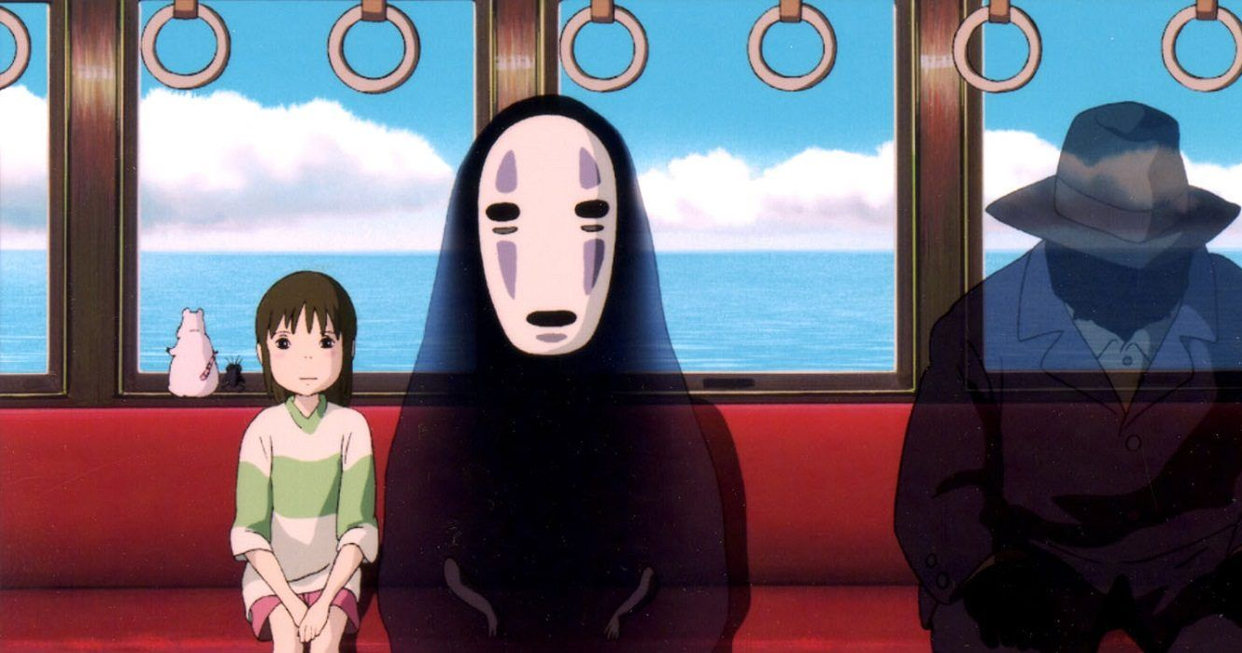There’s also been a huge amount of innovation in Japanese animation over the same time period, particlarly from Hiyao Miyazaki and his Studio Ghibli. Miyazaki largely uses traditional hand drawn cell animation techniques to create distinctive and elaborate fantasy universes and has produced a string of modern animated classics including *Princess Mononoke*, *Spirited Away* and *Howl’s Moving Castle*. Read more about Studio Ghibli on the BFI website below:

<https://www2.bfi.org.uk/news-opinion/news-bfi/features/where-begin-studio-ghibli>

<https://www2.bfi.org.uk/news-opinion/news-bfi/lists/studio-ghibli-five-essential-films>

**Aardman:**

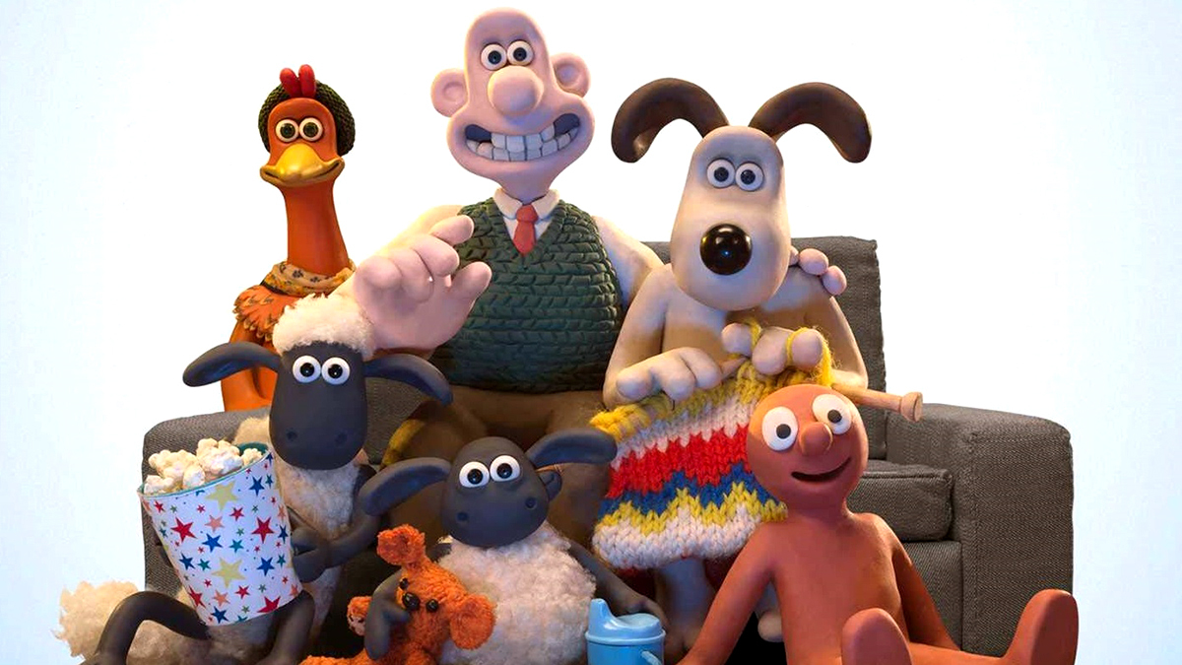Not to be outdone, modern British animation has also been highly original – particularly the work of Nick Park and his studio – Aardman. Unlike Pixar which takes a computer generated approach to animation and Studio Ghibli which uses traditional hand drawn techniques, Aardman uses what is known as a stop motion technique – one that involves making movements to figures made out of plasticine, photographing them and then editing the resulting shots together to create a film – see also films such as *King Kong* (1933) <https://www.youtube.com/watch?v=MMNICLfHE3M> and Ray Harryhausen’s famous skeleton battle scene from the 1963 film *Jason and the Argonauts* <https://www.youtube.com/watch?v=vUK3VCW2LH0> for earlier examples of this animation technique. You’ll be familiar with Aardman films such as the Wallace and Gromit and Shaun the Sheep series.

**Disney – The Studio That Started It All:**

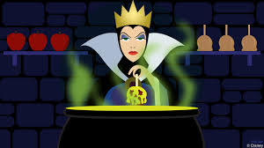Arguably none of the modern animation studios mentioned above would have existed without the pioneering work of the earliest and most famous producer of film animation – Disney. Founded in 1923, during the silent era, Disney developed many of the techniques and approaches to narrative and genre that we associate with animated filmmaking today. Their approach relied on the painstaking and labour intensive hand drawn cell animation process, pulled off with levels of skill, attention to detail and naturalism of characters’ movement that set a very high standard for animated filmmaking from then on. If you haven’t seen films like *Snow White and the Seven Dwarfs*, made in 1937 and the first animated feature film ever produced, you should watch them. The technical skill that has gone into making this film is pretty remarkable, even more so when you think that no one had ever produced this kind of animated feature before. My personal favourites from Disney’s “classic” period include *Pinocchio* from 1941 and a much later film, *The Jungle Book* from 1967.

**Animated Film – Viewing List:**

You almost certainly won’t need any introduction to some of the greatest contemporary animated movies – the likes of *Monsters Inc*, *The Toy Story* series, *Shrek* or *The Incredibles* – if you haven’t seen any of these, run to your nearest screen immediately and watch them! What follows is a list of animated films you might be less familiar with and might be interested in watching.

* ***Shaun the Sheep Movie*** – Aardman/Nick Park (2015)
* ***Up*** – Disney/Pixar (2009)
* ***Spirited Away*** – Studio Ghibli/Hiyao Miyazaki (2001)
* ***The Jungle Book*** – Disney (1967)
* ***Pinnochio***– Disney (1941)

**Interested in Working in Animation?:**

A good first place to look if you’re interested in exploring a career in animation is the Future Film workshops offered by the BFI – they’re currently offering two animation courses. Past CHSG students have participated in the Future Film programme and got a lot out of the experience. You have to be sixteen to take part but they’re almost certain to be offering similar courses in 2022 if you’re not old enough this time round or simply want to wait until you’ve actually started studying Media or Film at A Level before starting something like this. Links below:

<https://www.bfi.org.uk/bfi-film-academy-opportunities-young-creatives/bfi-film-academy-specialist-courses/bfi-film-academy-specialist-course-animation-vfx>

<https://www.bfi.org.uk/bfi-film-academy-opportunities-young-creatives/bfi-film-academy-specialist-courses/bfi-film-academy-animation-specialist-course-stop-motion-production>

**Film Website of the Month – www.bfi.org.uk:**

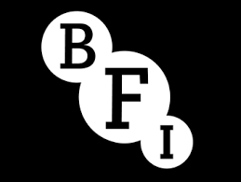You may have noticed that I’ve pasted a lot of links in this newsletter to the BFI website, the Future Film Academy (mentioned above) is also run by the BFI. If you’re studying film, the BFI (or The British Film Institute) is definitely an organisation you need to be aware of. The BFI is run on a non-profit basis and receives money from the government and other public sources. It has a hugely varied range of responsibilities. It is one of the biggest funders of film in the UK – distributing lottery funding to UK filmmakers. It is responsible for managing the British film archive, for running the annual London Film Festival, for running media and film education programmes for teachers and students, for running the biggest film and television library in the country and for publishing Sight and Sound, the UK’s most significant film magazine. Their website is a very useful first port of call if you want to find out about film movements, film genres and filmmakers. Simply google the name of the filmmaker/film movement/film genre and tonnes of useful information should come up. [**www.bfi.org.uk**](http://www.bfi.org.uk)