 

**Early Childhood Development Year 12 Bridging Work**

Course Leader: Miss N. Kenny [nkenny@carshaltongirls.org.uk](mailto:nkenny@carshaltongirls.org.uk)

BTEC Nationals

Early Childhood Development (AAQ) Extended Certificate

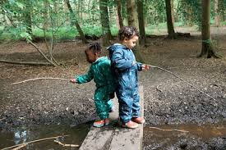

In preparation for your course, we would like you to complete two tasks and to bring this work in with you in September.

**Task 1**

Produce an A4 poster on how the brain develops from conception through childhood, to adulthood. In this, you must consider the role of neurons, and you must give a detailed explanation of how neurons work. Use diagrams to support your explanation. Include your sources.

**Task 2**

Design a literacy activity for a child aged 2 years and 3 months. You will need to carry out research into appropriate activities for the age group. You must put together an activity plan, in table format, where you show what all of the aspects you have considered when planning the activity. Record your sources.

This governmental website will give you some ideas, to get you started:

[**https://help-for-early-years-providers.education.gov.uk/areas-of-learning/literacy**](https://help-for-early-years-providers.education.gov.uk/areas-of-learning/literacy)

**The Course**

**Text Book**

This is a new course and the text book has not yet been released. You will be given details as soon as it is available.

**Resources**

Please equip yourself with lined paper, a strong lever arch file, some plastic pockets, a mini white board and pens.

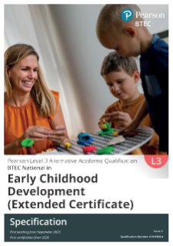

Link to Specification: Early Childhood Development (AAQ) | Pearson qualifications

Units:

The qualification has four units, all of which are mandatory, covering the following topics:

1. Children’s Development – Externally examined
2. Keeping Children Safe – Externally examined
3. Play and Learning – Internally assessed
4. Research and Reflective Practice in an Early Childhood Setting – Internally assessed.

We expect you to arrange to spend time in a work placement with children from 0-8 during your study periods and/ or during your Year 12 Work Experience Week.