**Carshalton High School for Girls –**

Get Ready for Film Studies **January Edition – Horror**  
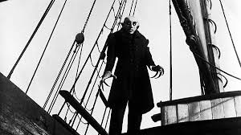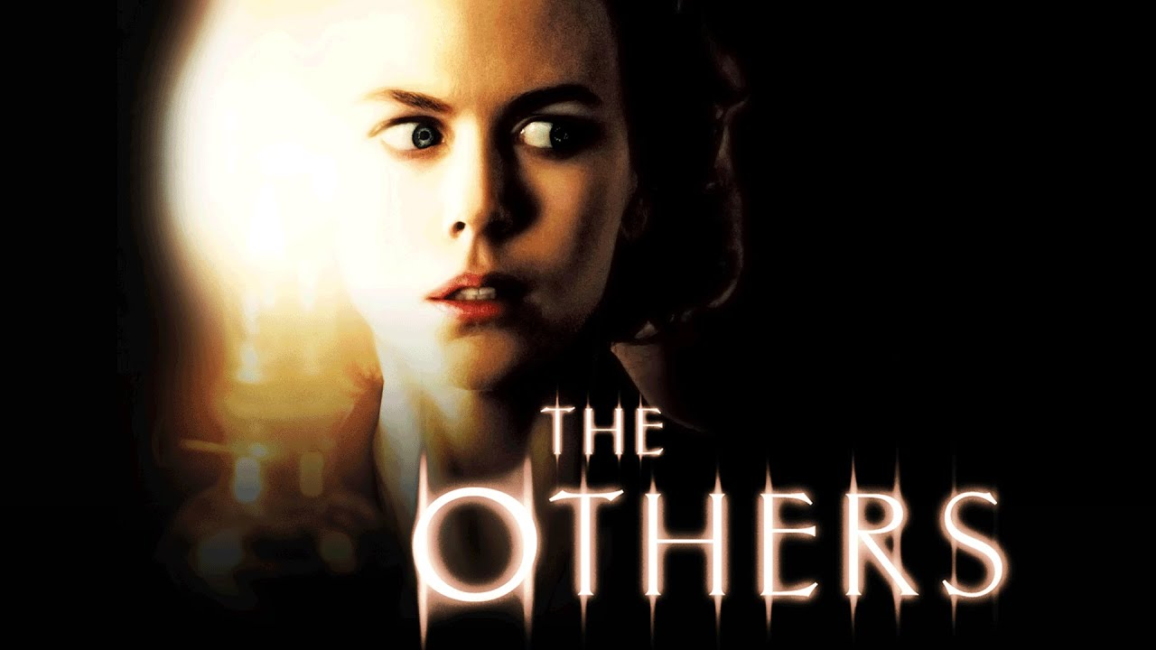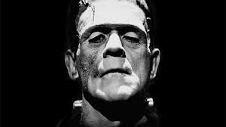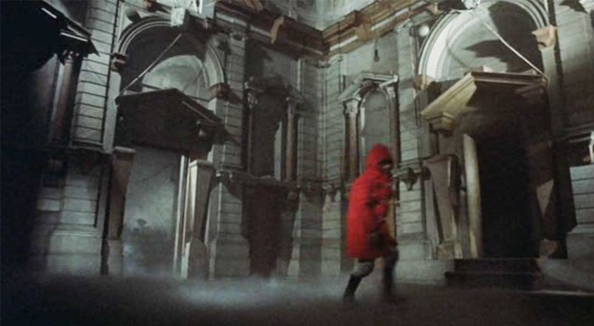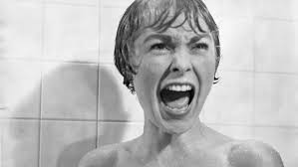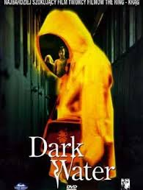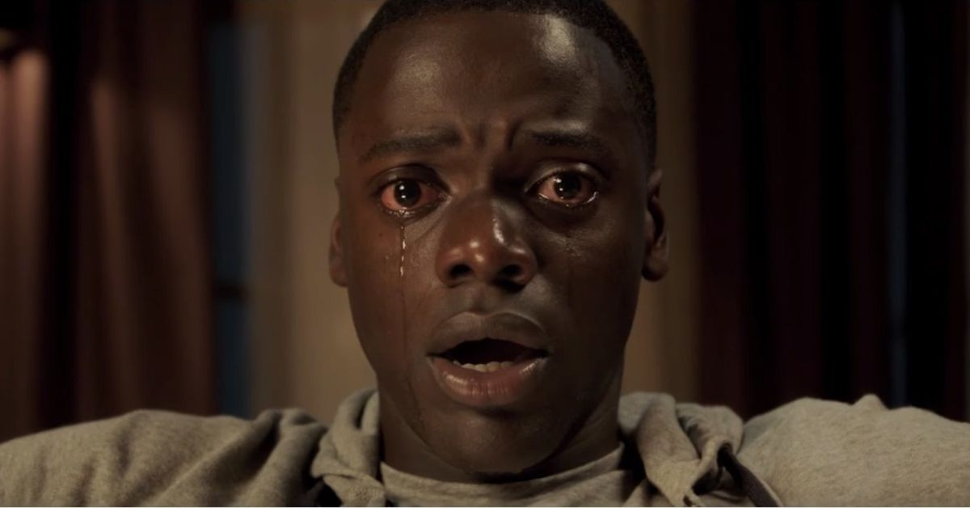  
   
 Welcome to the January edition of our Get Ready for Film Studies newsletter. This month our attention turns to the Horror genre. Halloween would probably be a more appropriate time for this but in the absence of an autumn edition of our newsletter a dark winter month will have to do! Horror is a film genre that has been around since the silent era and arguably was present in literature and theatre long before the invention of film and the cinema. There is something particularly appealing to film audiences though about exploring their deepest primal fears in a space that is dark but that they ultimately know is safe and somewhere where they know they are surrounded by other people. Basically film audiences enjoy the experience of being scared in a controlled way!

You’ll notice that for obvious reasons all our horror film recommendations are15 certificates and under, however you may have found out from your own experience of watching horror films that in many ways it’s the 15 certificate films you have to watch out for! As with all the films we recommend in all the newsletters the viewing list here isn’t compulsory.

**Horror in the Silent and Early Sound Era:**

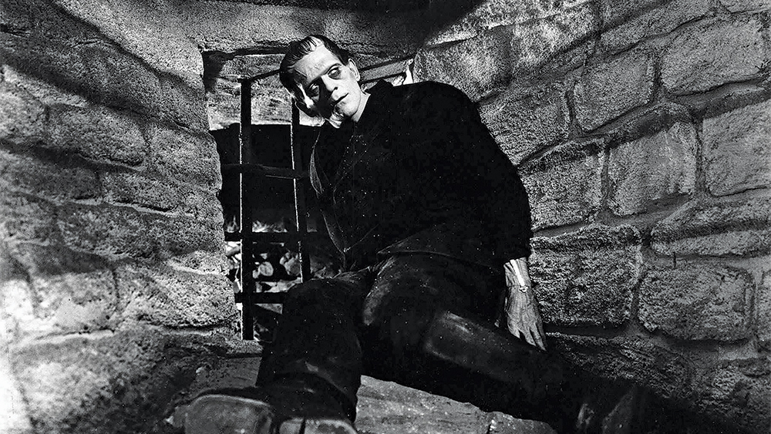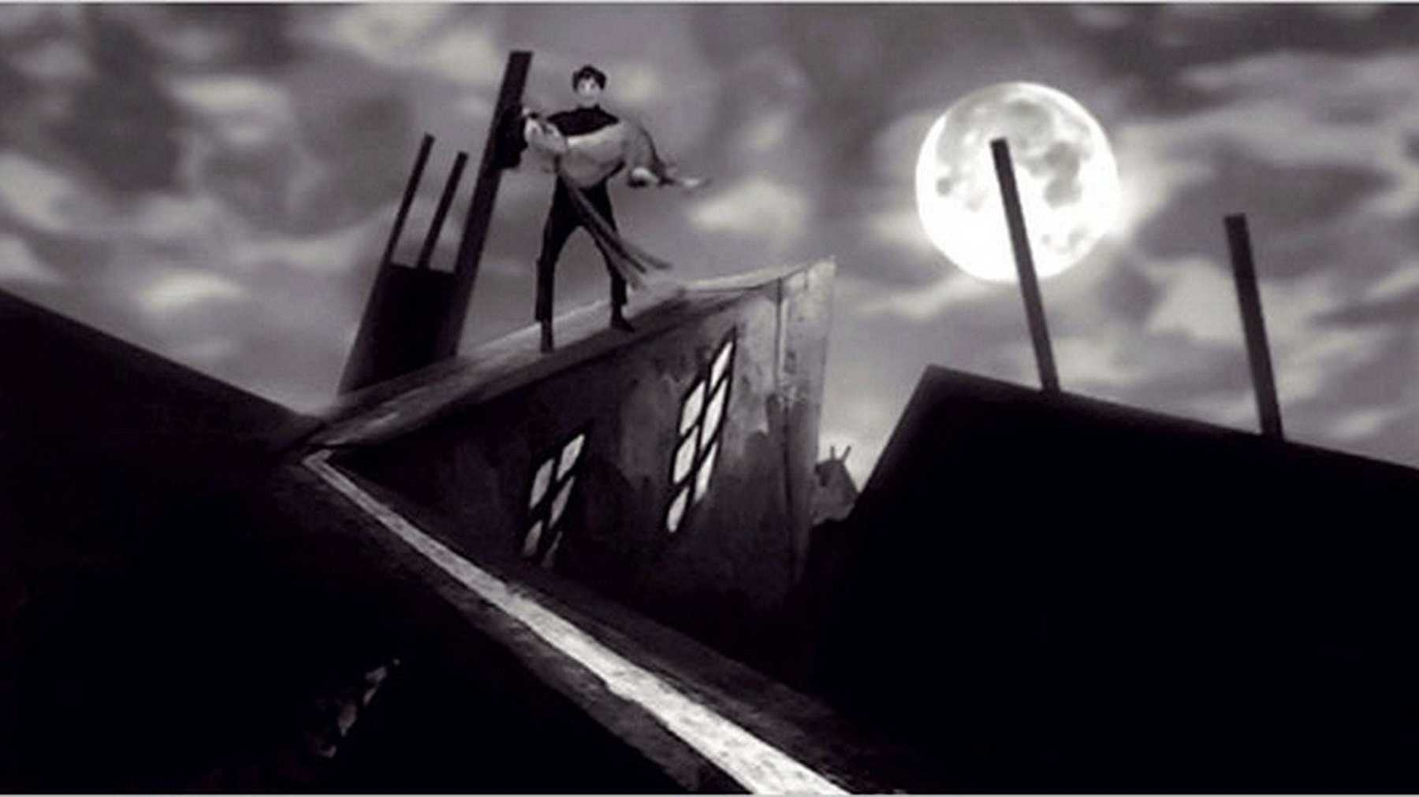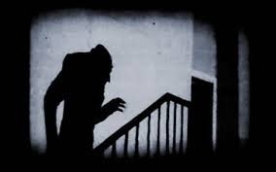Quite a lot of films that could be described as horrors were produced in the silent era, particularly by German filmmakers who were part of what was known as the Expressionist film movement. Their films, including *Nosferatu* and *The Cabinet of Dr Caligari* were largely re-tellings of horror stories drawn from literature such as Bram Stoker’s novel *Dracula*. Directors of this movement were highly creative in their use of exaggerated set, props, make up and lighting to generate a sense of fear in their audiences – see the famous still of a silhouetted vampire climbing up a flight of stairs towards his victim from the 1922 film *Nosferatu* for an example of this. When sound came in the late 1920s, it was the American film industry that took over as the major producer of horror films, with Universal the studio that specialised in the genre. *Frankenstein*, produced in 1931, is probably their masterpiece, with make up and production design so creative and original that their vision of Dr. Frankenstein’s monster has become the defining one.

**Horror in the Mid-Late 20th Century:**

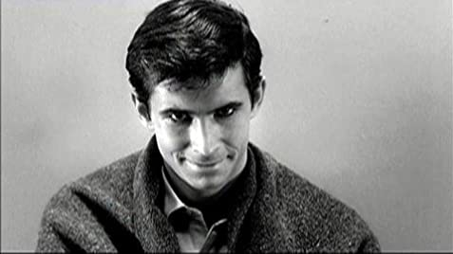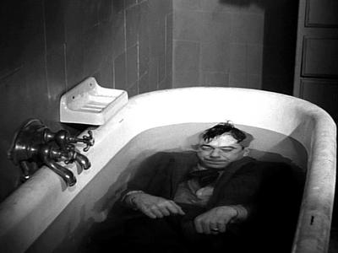 As the 20th century progressed, the conventions of the horror genre changed alongside rapidly shifting social attitudes and expectations. As television ownership became more widespread and offered the film industry some serious competition for the first time and young people became a key target audience for film studios it became increasingly acceptable to show acts of violence and gore – much of which was now shown in colour. The great director Alfred Hitchcock picked up on the growing taste for horror among young audiences in his 1960 film *Psycho*, a film notable (amongst many other things) for its human, rather than supernatural, antagonist. While many of the most famous horrors of the later part of the 20th century were ultra violent slashers some of the most interesting films of the genre from this period were more subtly unsettling psychological horror films – many of which were produced outside of the American film industry. If it’s something that interests you films like French director Georges Henri Clouzot’s 1955 film *Les Diaboliques* (*The Devils*) is well worth watching and was 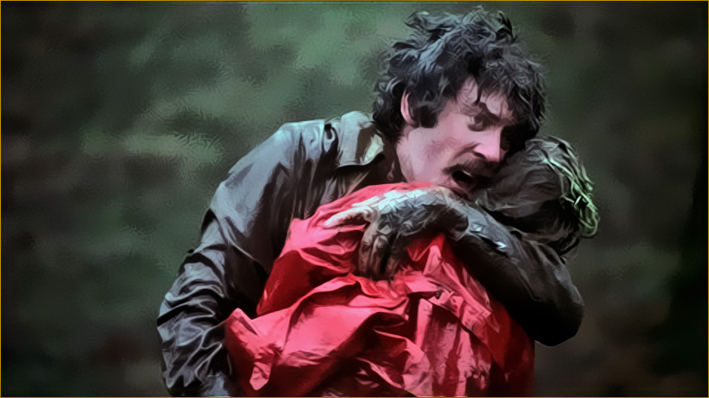a huge influence on *Psycho*. Many of the British horrors produced in the 1970s are also worth a watch – the greatest being (in my opinion) Nicolas Roeg’s 1973 film *Don’t Look Now*.

**Contemporary Horror:**

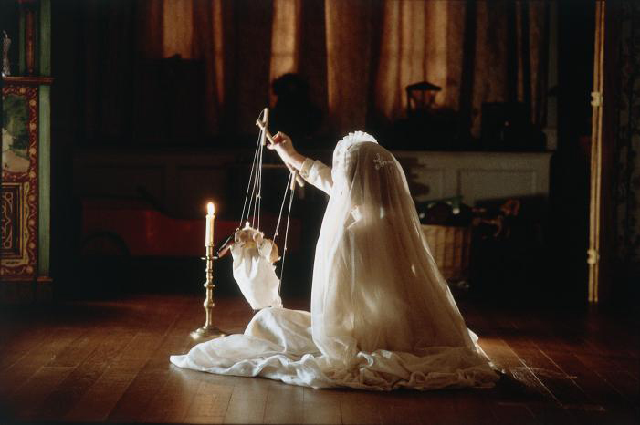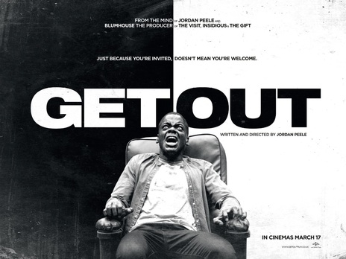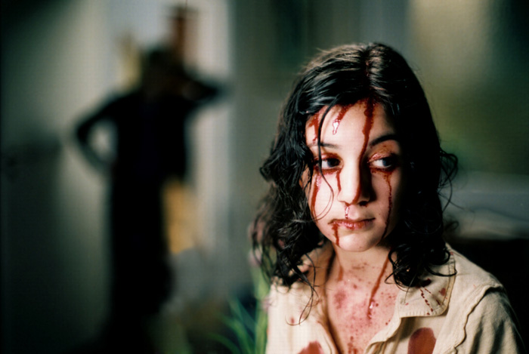 A number of trends have developed in modern horror filmmaking. By the early 2000s audiences were so familiar with the conventions of the horror genre that the only way of making use of them seemed to be to either draw more attention to them or spoof them in franchises like *Scream* and *Scary Movie*. However, there were attempts to take advantage of digital technology to produce ultra realistic and ultra low budget horrors such as *The Blair Witch Project* and *Paranormal Activity*. Arguably the most successful horrors of recent years have been in the unsettling psychological mould of earlier films such as *Psycho*, *Les Diaboliques* or *Don’t Look Now*. *The Others*, made (in English) by Spanish director Alejandro Amenábar in 2001 is well worth a watch. Japanese and Korean directors have also done interesting new things with the genre, Hideo Nakata’s 2002 film *Dark Water* is well worth a watch, although be warned - it’s pretty unsettling in spite of its 15 certificate. Other contemporary horror filmmakers have used the genre to draw parallels with wider social issues. Swedish director Tomas Alfredson’s 2008 film, *Let the Right One In*, for example uses many of the conventions of the vampire movie to draw attention to the status of marginalised groups in contemporary Swedish society. Jordan Peele’s 2017 film *Get Out* uses the horror genre to explore issues of race and the status of African Americans in modern America.

**Horror Film – Viewing List:**

* If you’re feeling adventurous you might want to try a bit of early horror like ***Nosferatu*** (FW Murnau, 1922)or ***Frankenstein*** (James Whale, 1931).
* You should absolutely try to watch Alfred Hitchcock’s ***Psycho*** before starting the course. We will study key scenes from it in the first term of Year 12.
* More modern horror films that it might be appropriate for us to advise you to watch might include ***The Others***, (Alejandro Amenábar, 2001) and ***Let the Right One In*** (Tomas Alfredson, 2008). While ***Get Out***, directed by Jordan Peele and released in 2017, has a 15 certificate it is more violent than the other films listed here – so approach with caution. However it is a good film and one that definitely does something new with the genre, so it’s worth a watch.

**Online this Month:**

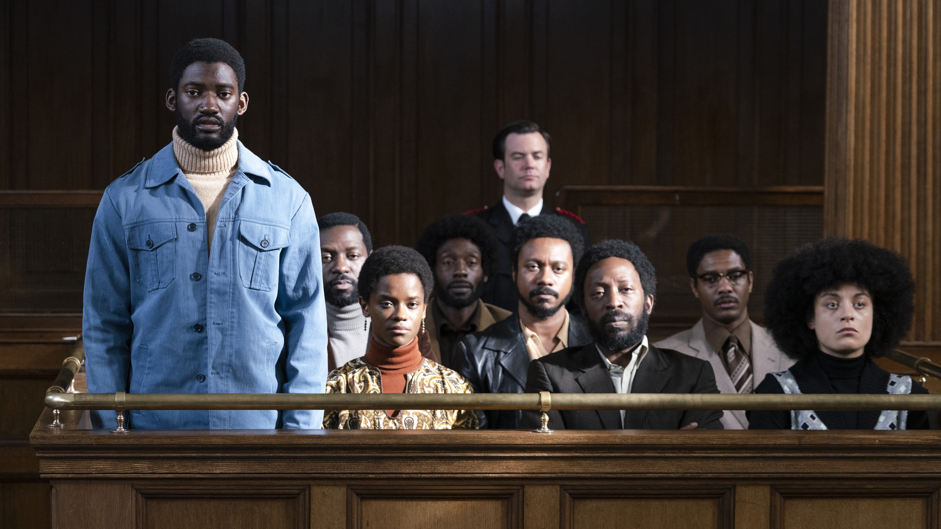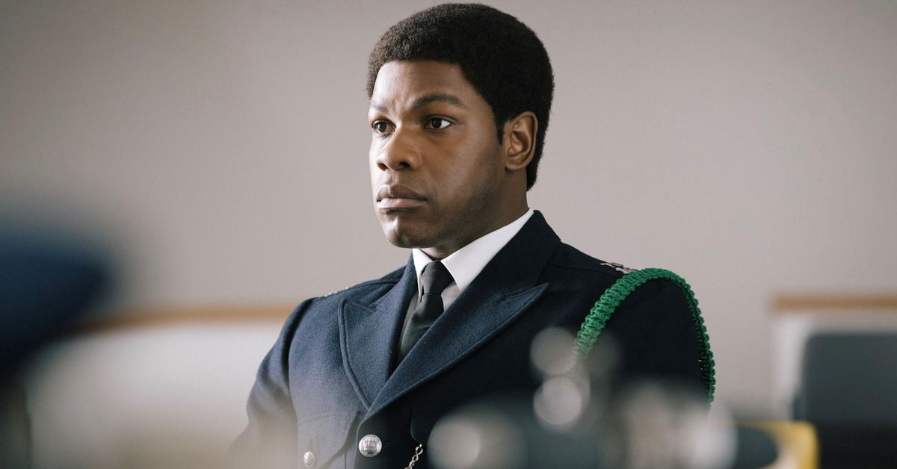We move away from the horror genre for these recommendations. The *Small Axe* series, five films by Oscar winning British director Steve McQueen. McQueen made his name as an artist rather than a filmmaker and moved into feature filmmaking in 2008, winning the 2014 Best Picture Oscar for *12 Years a Slave*. In this series of five films, made for BBC television, he explores different aspects of black British experiences in the 1970s and 1980s. The films have been very well reviewed and all five are available free on iPlayer for a year.

<https://www.bbc.co.uk/iplayer/episodes/p08vxt33/small-axe>

Read *Guardian* film critic Peter Bradshaw’s review of the first of the five films, *Mangrove*, here:

<https://www.theguardian.com/film/2020/sep/25/mangrove-review-racial-prejudice-steve-mcqueen-small-axe>