**Carshalton High School for Girls –**

Get Ready for Film Studies **March Edition – Teen Movies**

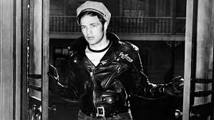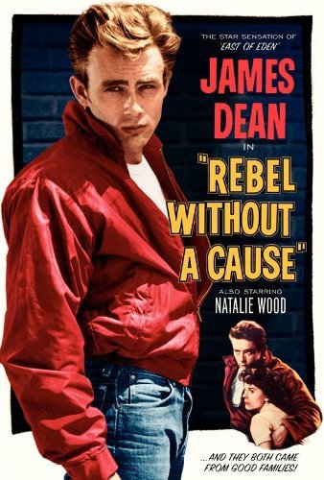 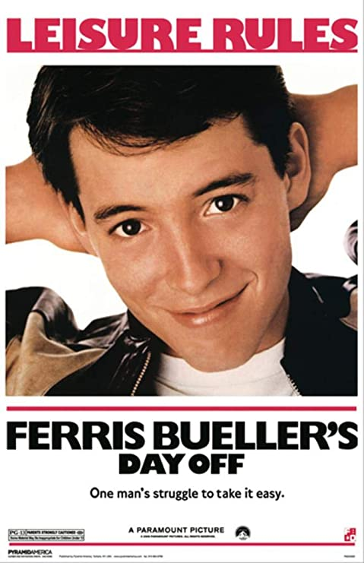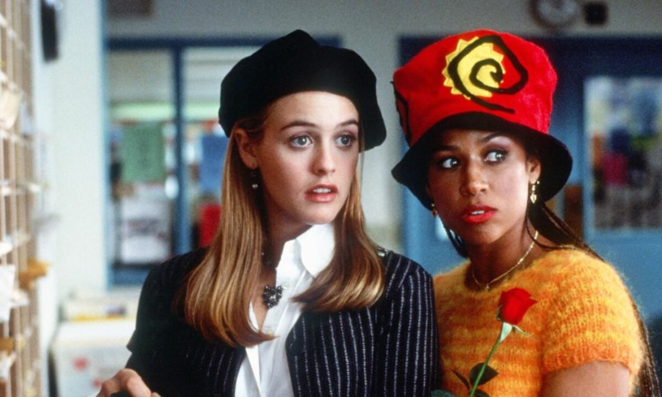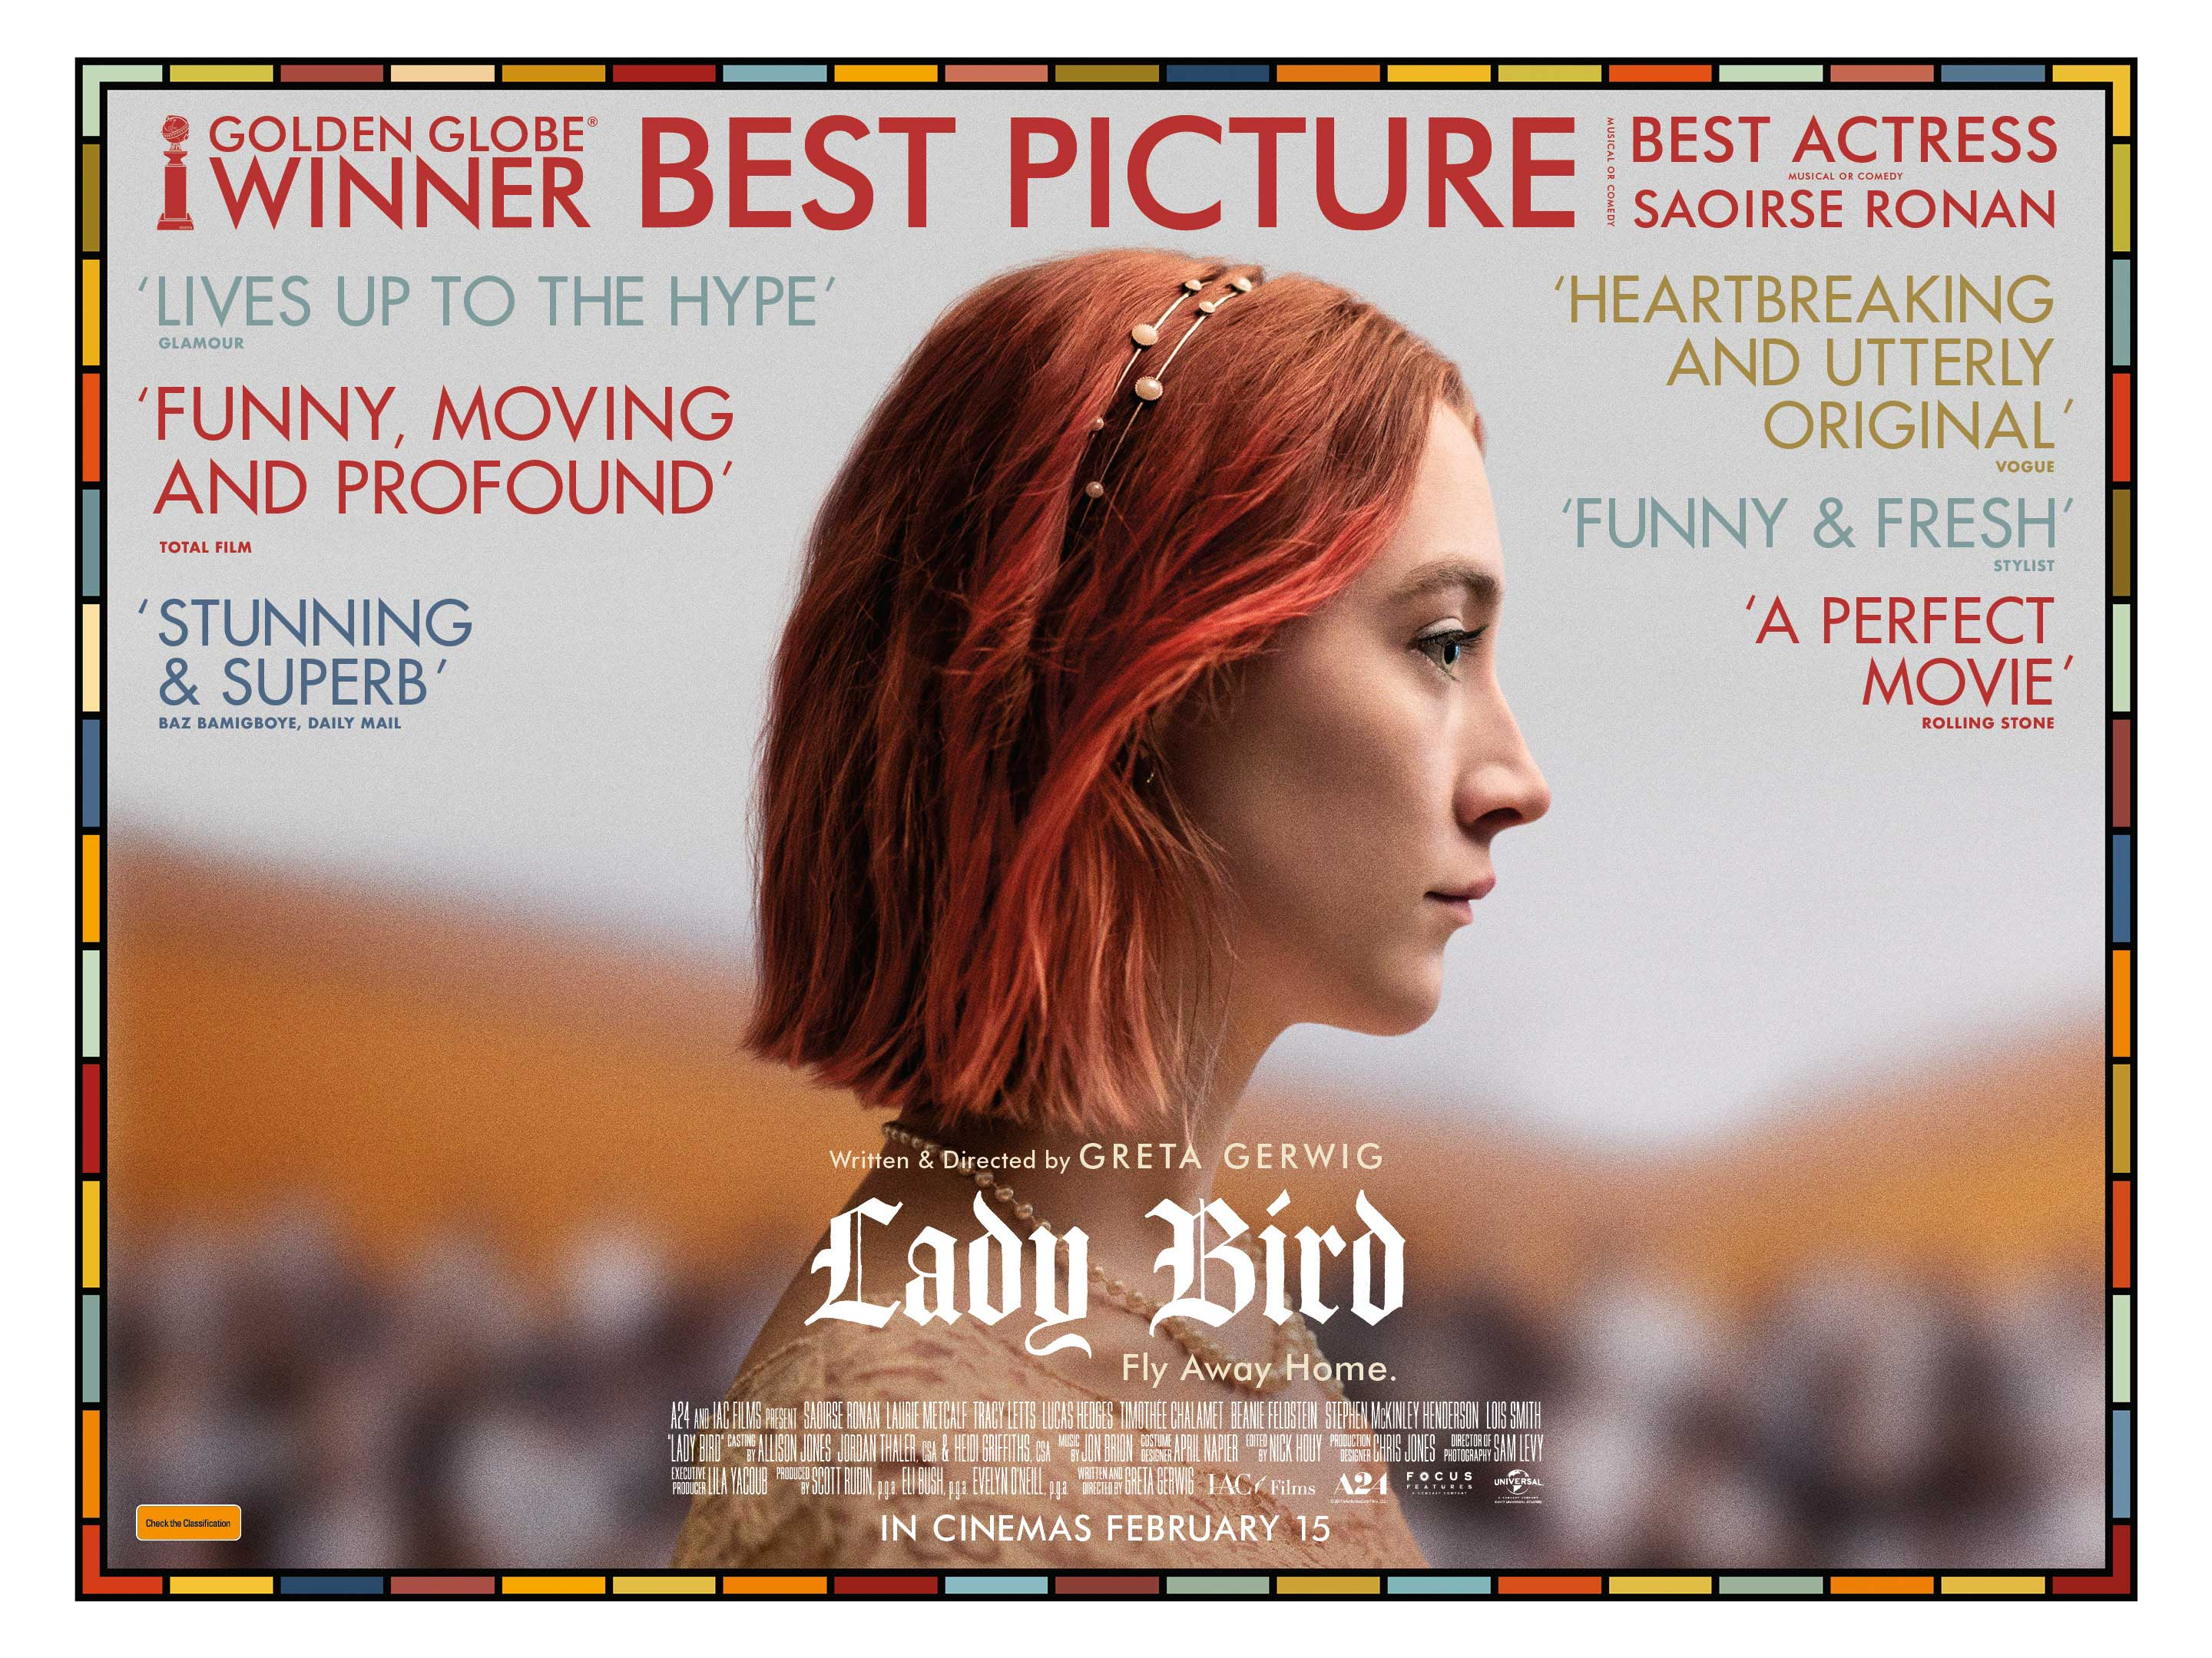

Welcome to the March edition of our Film Studies newsletter. This month our attention is turning to teen movies. Although teenagers have obviously always been around, the idea of them as a separate group of people with their own tastes and interests, and certainly the idea of them as a separate audience for films, is a relatively recent one. We’re going to look at some key “teen” films this month, you might also want to look at this list, put together by the BFI outlining what they consider to be the best teen movies of all time: <https://www2.bfi.org.uk/news-opinion/news-bfi/lists/10-great-teen-films>

**The Birth of the Teen Movie – The 1950s and 1960s:**

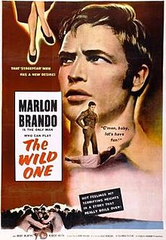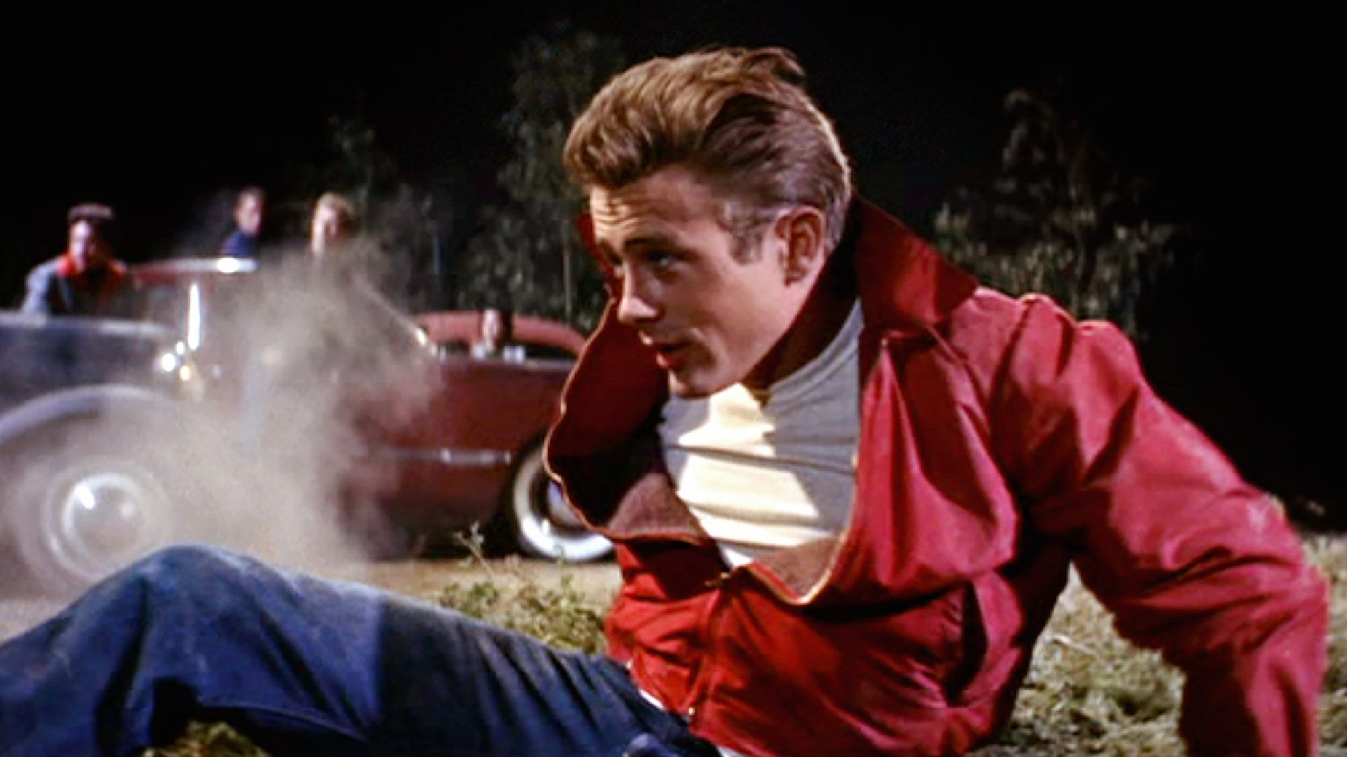 The 1950s and particularly the 1960s were decades of big social change. One of the reasons for this was that there had been a “baby boom” at the end of the Second World War, meaning that a decade and a half later populations of western countries like Britain and America were becoming considerably younger, with large numbers of people in their teens and early twenties. These young people didn’t necessarily share the values of their parents and wanted films and music in particular that reflected their outlook on life. Before the 1950s films had been aimed at an almost exclusively adult audience, but this population “boom” of young people opened up a significant new market for businesses like record labels and film studios, who realised they could make a considerable amount of money from it. The concept of the teenager, rock and roll and the teen movie were born!

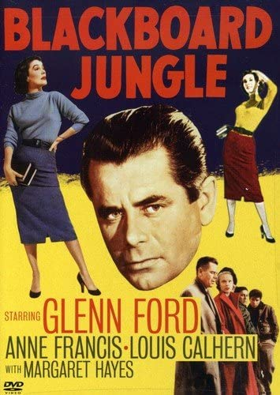 Films aimed specifically at teenagers started to emerge in the early1950s, a time when very few households owned TVs and where the cinema played a much bigger role in people’s lives than it does today. Films such as László Benedek’s ***The Wild One*** (1953), Nicholas Ray’s ***Rebel Without a Cause*** (1955) and Richard Brooks’ ***The Blackboard Jungle*** (1955) featured teenage and young adult characters and storylines that revolved around teenage rebellion, juvenile delinquency and a largely sympathetic representation of young characters who chose to live lives outside of the boundaries of mainstream society. The films also made use of contemporary settings, a naturalistic style of performance and a groundbreaking approach to music, using modern scores or soundtracks based around the kind of popular rock and roll music young people of the time would have listened to. The “teen” films of this period made huge stars of their young lead actors, perhaps most famously James Dean and Marlon Brando, and arguably opened the door to a new generation of young filmmakers and new ways of making films aimed at a younger audience.

**Teen Movies from the 1980s to the Present Day:**

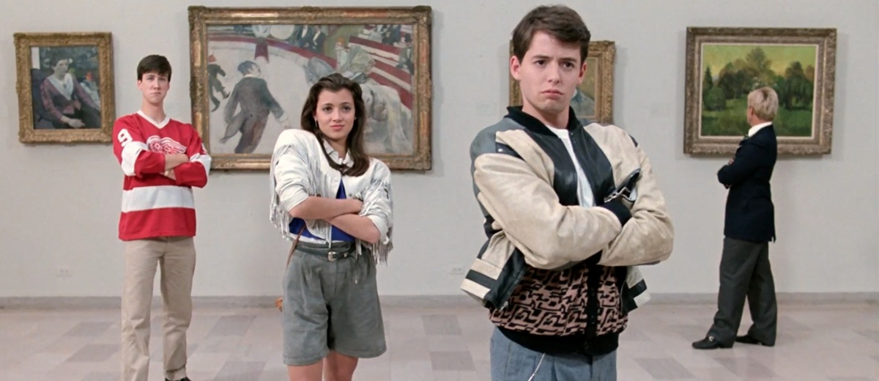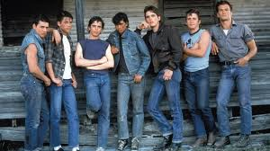 The late sixties and early 1970s were a time of huge change and experimentation in American cinema (a period of film history that has become known as New Hollywood - more on that later in the year). This period of film history was a huge influence on a new generation of teen movies released in the1980s – a decade that has been described by the BFI as “a golden age for the American teen film” (see the BFI’s list of the best 1980s teen movies here: <https://www2.bfi.org.uk/news-opinion/news-bfi/lists/10-great-american-teen-films-1980s>). New Hollywood director Francis Ford Coppola’s 1983 coming of age film ***The Outsiders***was perhaps the first significant “teen” film of the 1980s andlinked to the earlier generation of teen movies by making use of a 1960s setting and tragic storyline. Many of the teen films of the 1980s though took a more comic turn, particularly those of director John Hughes who made the teen movie genre his own in the 1980s, making a string of hit films that included ***The Breakfast Club***,***Weird Science*** and ***Pretty in Pink***. Perhaps his most notable film is ***Ferris Bueller’s Day Off****,* released in 1986, a comedy that tracks the chaos left in the wake of the title character on a day when he plays truant from school. 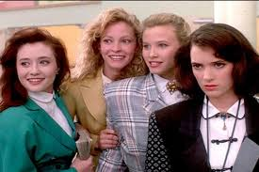The 1989 film ***Heathers***, a very dark comedy directed by Michael Lehmann and set in a high school,is also well worth a watch. As the 80s moved into the 90s the concept of the teen comedy continued, but this time with more of a focus on female central characters. The pick of the bunch of the teen movies from this period are probably ***Clueless*** (1995), a reimagining of Jane Austen’s 1815 novel *Emma* set in a 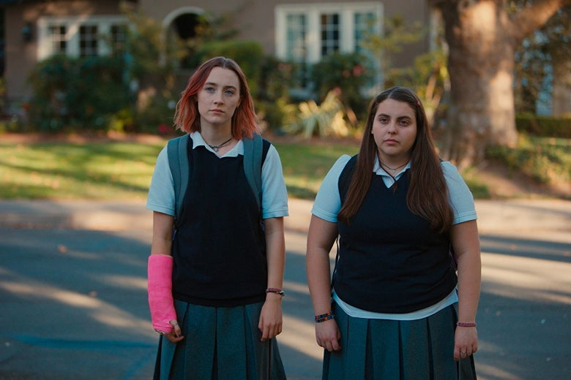contemporary American high school,and the high school dark 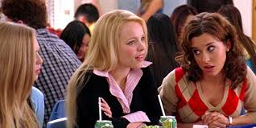comedy***Mean Girls***(2004). The teen movie genre has become financially very successful for the film industry and now makes studios a considerable amounts of money. However, the teen movie has evolved in recent years. Not all modern teen movies are high budget box office hits. While not being a commercial movie aimed specifically at teenagers, Greta Gerwig’s low budget film ***Lady Bird*** (2017) is clearly about the experience of being a teenager. While it’s quite different to the teen films of the 80s, 90s and 2000s, in focusing on the fun, freedom and experimentation of teenage life on the one hand and the anxiety and insecurity of it on the other (and the comedy this has the potential to generate), it also very much follows in their tradition. It’s also well worth a watch.

**Teen Films to Watch**:

We’re going to recommend films that span the eras mentioned above. Links are for Amazon but other platforms are available! Happy viewing:

Nicholas Ray – ***Rebel Without a Cause*** (1955): <https://www.amazon.co.uk/Rebel-Without-Cause-James-Dean/dp/B00ET2GO8W>

John Hughes - ***Ferris Bueller’s Day Off*** (1986):

<https://www.amazon.co.uk/Ferris-Buellers-Day-Matthew-Broderick/dp/B00FYHA6F8/ref=sr_1_1?crid=1VSINIGOQVFQG&dchild=1&keywords=ferris+buellers+day+off&qid=1615194678&s=instant-video&sprefix=Ferris+Bueller%27s%2Cinstant-video%2C174&sr=1-1>

Amy Heckerling – ***Clueless*** (1995): <https://www.amazon.co.uk/CLUELESS-Wallace-Shawn/dp/B00FYNMEVQ/ref=sr_1_2?dchild=1&keywords=clueless&qid=1615194878&s=instant-video&sr=1-2>   
Greta Gerwig – ***Lady Bird*** (2017): <https://www.amazon.co.uk/Lady-Bird-Saoirse-Ronan/dp/B079RWGWRK/ref=sr_1_1?dchild=1&keywords=ladybird&qid=1615195095&s=instant-video&sr=1-1>

**Work Experience Opportunities Update:**

I’ve shared work experience opportunities in previous newsletters but some new things have come up recently:

**BFI Future Film Academy:**

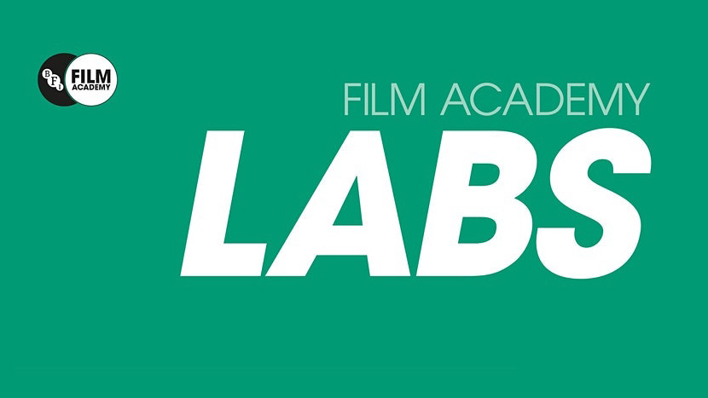 The BFI have launched some new online courses as part of their Future Film Academy:  
  
**BFI Academy Labs:**   
FREE monthly Saturday events for 16-25 year olds - <https://whatson.bfi.org.uk/Online/default.asp?BOparam::WScontent::loadArticle::permalink=bfifilmacademylabs&BOparam::WScontent::loadArticle::context_id>=

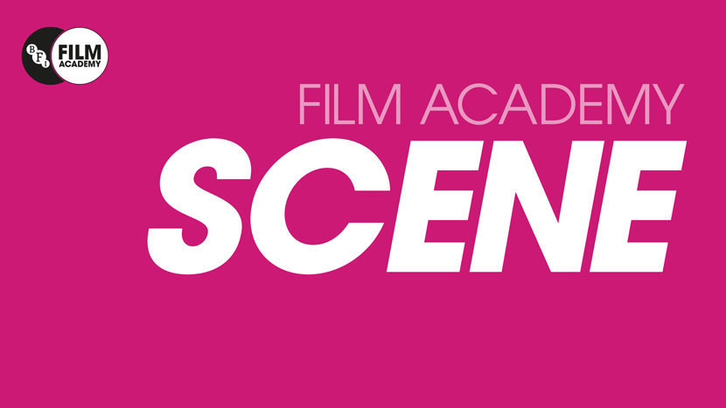**BFI Academy Scene:**   
Live online interviews with young filmmakers every Thursday evening. FREE for 16-25 year olds who can submit questions for the filmmakers. A great opportunity to see others’ work and make connections: <https://whatson.bfi.org.uk/Online/default.asp?BOparam::WScontent::loadArticle::permalink=scene2018&BOparam::WScontent::loadArticle::context_id>=

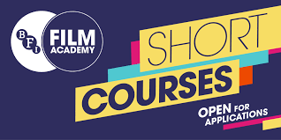**BFI Academy Specialist Courses:** These are courses I have mentioned before but the BFI have now made them available online. Amazing opportunities if you can get a place on them – CHSG Film students have done so in the past: <https://www.bfi.org.uk/bfi-film-academy-opportunities-young-creatives/bfi-film-academy-specialist-courses>

**Fully Focused Productions:**

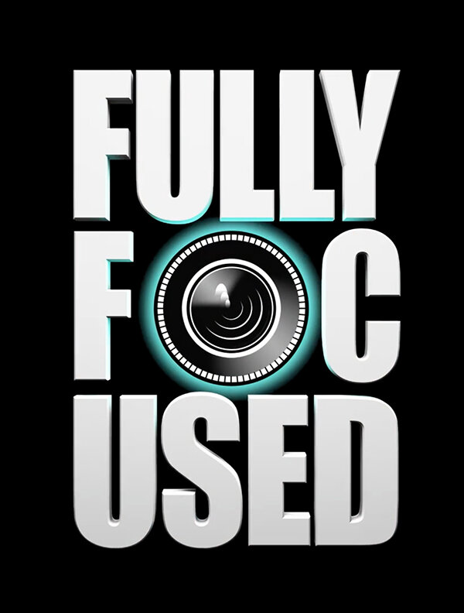 Fully Focused Productions is a charity that runs a range of programmes to help young people enter the film industry. They run a range of FREE online filmmaking masterclasses and sessions. Follow their socials (@ukfullyfocused) for details of upcoming workshops and masterclasses on everything from sound to editing, cinematography, production and much more. https://www.fullyfocusedproductions.com/