**Carshalton High School for Girls –**

Get Ready for Film Studies **February Edition – Silent Film**

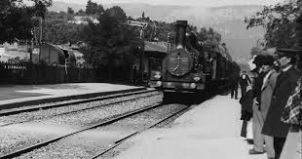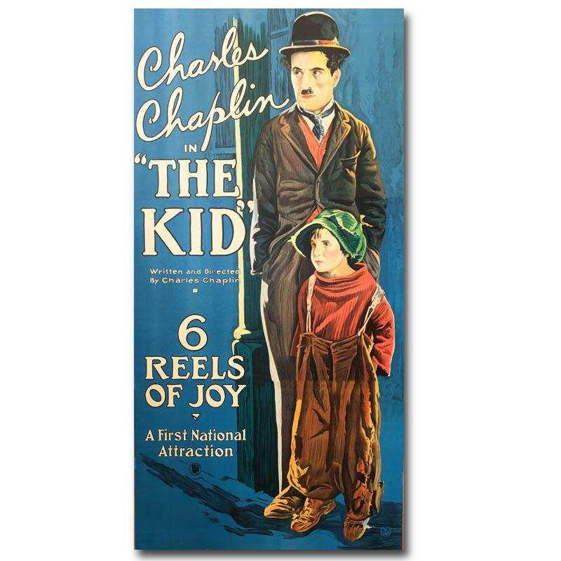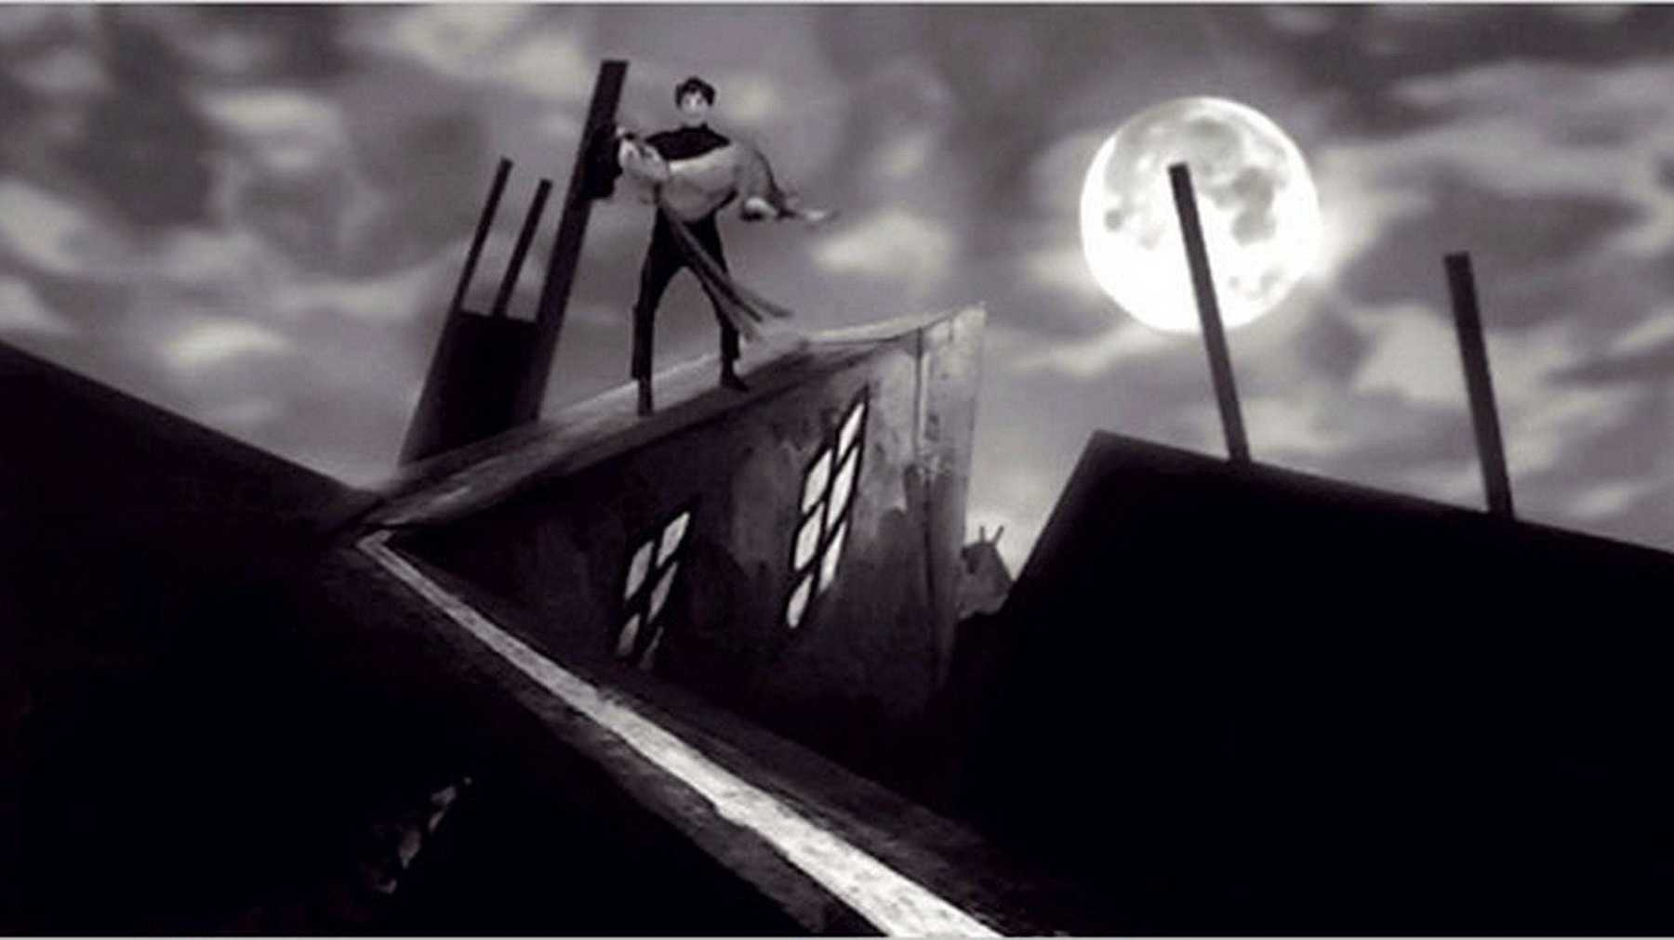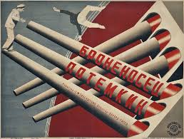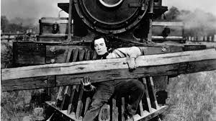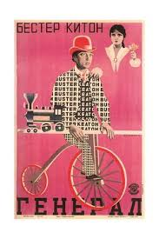   
 It’s February, and this month we go back in time and turn our attention to silent film. It can be easy to forget that film has only been around for 125 years - a fraction of a blink of an eye in the course of human history! It can also be easy to forget that until the late 1920s all film was silent. The silent era was a time of great innovation and experimentation, it’s a great period of film history to study and one of my favourite periods to teach - with the added benefit that virtually the whole output of the silent era is available for free online. There’s also learn a lot from silent filmmakers about how to tell stories in a purely visual way, something you can put to use in your own filmmaking work.

**The Very First Films:**

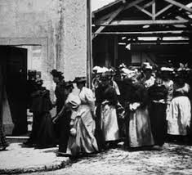The very first films ever made (in about 1895) were very short recordings of everyday events - a wall being knocked down, workers leaving a factory and so on. We’re very used to having films around as fairly regular parts of our lives and these are things that might not sound like anything particularly special to us. However, to the audience at the time they were made, who were seeing film for the very first time, they would have seemed amazing. Indeed, famously the audience for the Lumière brothers’ 1896 film of a train pulling into a station ran from the screening room in terror as the train approached on the screen in front of them!

**An Age of Experimentation:**

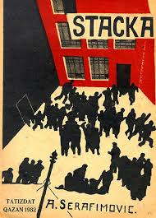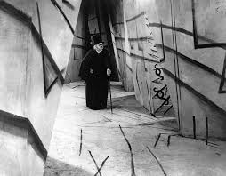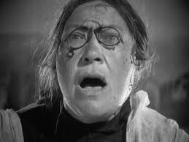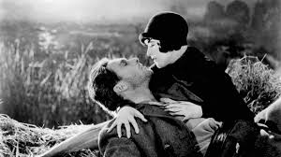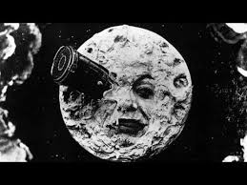 We’re used to a style of filmmaking now that uses camerawork, editing and things like costume, props and performance to create high levels of believability and realism. However it’s important to realise that this approach to filmmaking was developed over many decades. When filmmakers started making films in the late 1890s concepts that we take completely for granted now like editing, moving the camera, cutting between different strands of action or cutting backwards and forwards between two different characters as they speak hadn’t been thought of. Many very early films were shot from the front by a static camera in a single long take – a bit like filmed plays. As things progressed, the fact that film was a new medium whose “rules” hadn’t yet been established gave early filmmakers a significant amount of creative freedom, lead to a huge amount of experimentation and brought about the production of some truly great films. Across the world filmmakers explored approaches to filmmaking very different to those we’re used to today. In Germany the Expressionist movement used exaggerated sets and high contrast lighting to make films that reflected characters’ inner feelings. Leading Expressionist filmmaker F.W. Murnau went to work in Hollywood in the late 1920s where he produced what is considered by many to be his masterpiece *Sunrise* <https://www.youtube.com/watch?v=6NayFytQeBE>. In Russia a new style of filmmaking, known as Soviet Montage, emerged, mirroring the social change brought about by the communist revolution that had taken place in 1917. It experimented with a highly unconventional style of editing that relied on jump cuts – an approach we’re probably most familiar with now in music videos.

**American Silent Comedy (The 1910s and 1920s)**

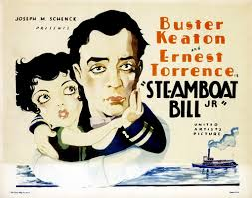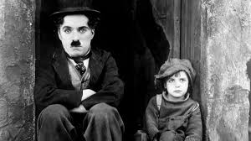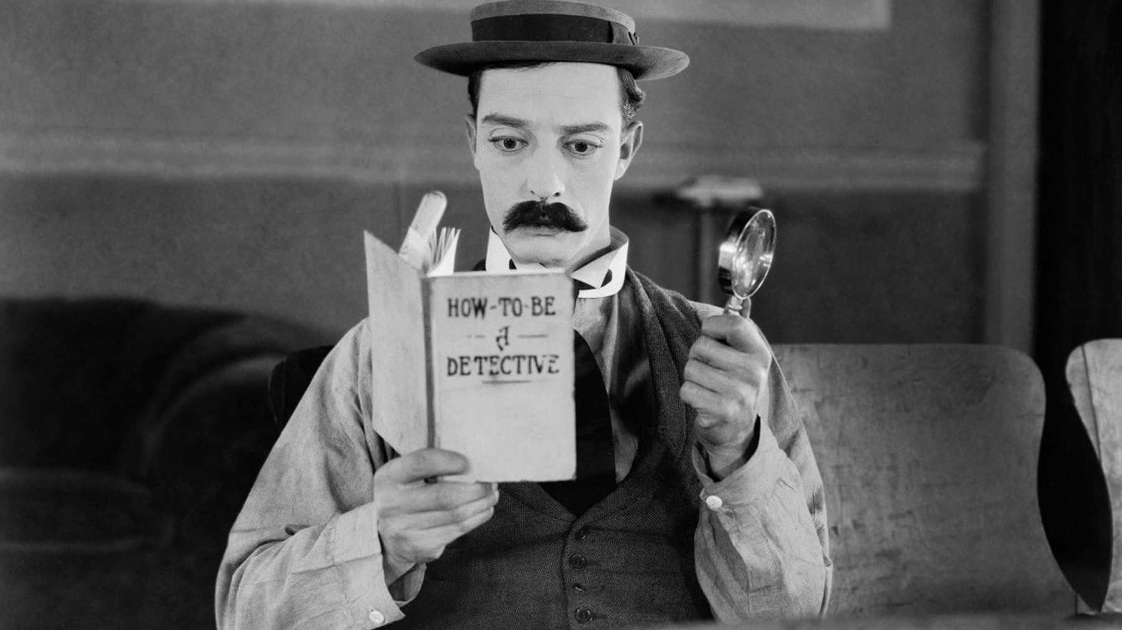However, perhaps the most accessible way in to silent film is through comedy. Comedy was one of the most significant genres of early cinema, making huge stars of its leading actors and directors like Charlie Chaplin and Buster Keaton. Comedies in the silent era would often be “two reelers”, short films played as part of a longer programme of films that might have also included newsreels and a longer feature film.  Early comedies, such as the Keystone Kops films produced by the Keystone Studios were simple, fast paced and relied on exaggerated “slapstick” humour.  However, as the comedy stars of the day became established and started to gain more creative control over their own films they began to produce longer and far more sophisticated and ambitious comedy features.  These included Chaplin films such as *The Kid*(1921) <https://www.youtube.com/watch?v=Z7-QdoofMq8> and *The Gold Rush*(1925) <https://www.youtube.com/watch?v=a-nyVGSEjyU> , and Harold Lloyd’s *Safety 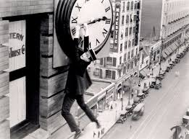Last*(1923) <https://www.youtube.com/watch?v=V-XZWZVVhvQ>. However, to my mind it is Buster Keaton who is the greatest of the silent comedy filmmakers. Three of his features, *The General* (1926), *Sherlock Junior* (1924) and *Steamboat Bill Junior* (1928) are masterpieces and seem just as fresh, modern and original as they did nearly 100 years ago when they were first released. His short films made between 1917 and 1923 are also pretty astonishing in their inventiveness and the sophistication of their stunts (all of which Keaton performed himself – breaking his neck in the process in one instance!)

**Films to Watch**:

We’re going to stick with silent comedy and Keaton here but other films from the silent era are easy to find online if you want to explore further.

Buster Keaton - ***Sherlock Junior*** (1924): <https://www.youtube.com/watch?v=3T29dVN9GRU>

Buster Keaton - ***The General***(1926): <https://www.youtube.com/watch?v=W-8Glmc7_XM>

Buster Keaton - ***Steamboat Bill Jr.***(1928):  <https://www.youtube.com/watch?v=n9QPfiLuQ9c>

Buster Keaton - **Short Films** (1917-1923): Nearly all Keaton’s short films are available on YouTube, I’m pasting the link to one here, ***Neighbors***, from 1920, there are links to others on this YouTube page though. <https://www.youtube.com/watch?v=tM0SeH8rcBg>

**If You’re Feeling Adventurous:**

 You might want to have a look at Murnau’s Expressionist masterpiece produced on a Hollywood budget – *Sunrise*:

FW Murnau – ***Sunrise***(1928): <https://www.youtube.com/watch?v=y8Vjxw6cL7g>

**Online this Month:**

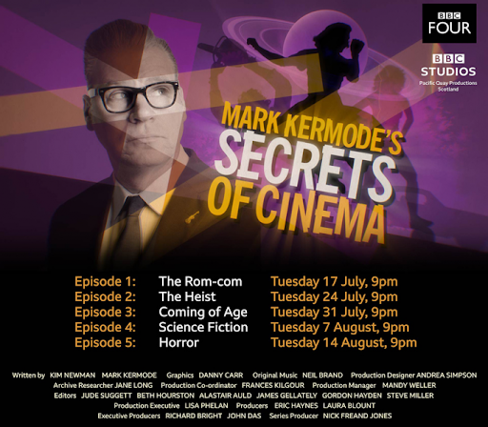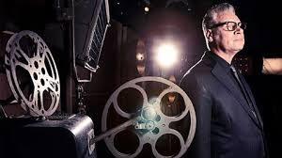Film critic mark Kermode currently has a series*, The Secrets of Cinema*, on BBC TV where he explores a different film style or genre every week. The programmes have been a bit of a mixed bag but are worth watching if you’re interested in film. They’re available on iPlayer:

<https://www.bbc.co.uk/iplayer/episodes/b0bbn5pt/mark-kermodes-secrets-of-cinema>