

**Level 3 Health and Social Care Bridging Work 2025**

Head of Department: Miss N. Kenny [nkenny@carshaltongirls.org.uk](mailto:nkenny@carshaltongirls.org.uk)

**An Important Aspect of Health and Social Care Practice – Hand Hygiene Techniques**

*Can you believe that in the 1840s handwashing by doctors was not a routine procedure? Did you know that in the 1800s hospitals were known as ‘houses of death’ because of the high mortality rates? Did you know that it was not until the 1980s that national hand hygiene guidelines were published in the US and the UK for healthcare workers? Did you know that approximately 5% to 10% of all hospitalised patients in the developed world acquire infections from health care workers who forgot to wash their hands?*

***Your task is to carry out research and present findings as a video, podcast, or PowerPoint presentation. The topic is ‘the development of hand hygiene techniques. Your work will be presented in your first week of Year 12. Record your sources. In your work, you should cover all of the aspects listed below. There are key terms included to support you in your research.***

**Ignaz Semmelweis and Puerperal Fever**

Semmelweis was a Hungarian doctor and is regarded as the father of hand hygiene. Key terms: autopsy; cadaver; maternity; puerperal fever; sepsis; mortality rates.

**Florence Nightingale, ‘Notes on Nursing’**

Florence Nightingale is arguably one of the most famous nurses in the world and is credited with revolutionising nursing practice. Key terms: data; statistics; dysentery; diarrhoea; typhoid; malaria.

**Louis Pasteur, ‘germ theory’ and Joseph Lister**

Pasteur’s germ theory proved that bacteria were the cause of disease. Joseph Lister, a surgeon, read Pasteur’s ideas and began to make links between bacteria and infection in surgery. Key terms: microbes; bacteria; pasteurisation; antiseptic; antiseptic surgery/antisepsis system; sterilisation.

**Handwashing Myths and Facts**

When should you use soap? When is it ok to use alcohol hand gel? Must you use hot water? Does it matter if you dry your hands? Can deaths really be prevented from simple handwashing? Do all healthcare workers know how to wash their hands? Key terms: healthcare-associated infection (HAI); hospital-acquired infection; nosocomial infection; decontamination; visibly soiled.

**The Ayliffe Technique and WHO 5 Moments of Hand Hygiene**

Graham Ayliffe developed his handwashing technique in the 1960s and it is the basis of all current handwashing. The World Health Organisation (WHO) has established global standards for hand hygiene and stipulates the 5 moments when hands must be cleaned (either by handwashing or hand rubbing). Key terms: healthcare environment; clean technique; aseptic technique; body fluid exposure risk.

**Your Course**

# BTEC Nationals Health and Social Care (AAQ) 2025

# BTEC Extended Certificate

This is a new course which has been updated to ensure that it meets the demands of a range of universities and employers, including the NHS and social care providers. We would like you to undertake a work placement during your study periods during your time in Sixth Form, to give you an understanding of the sector.



Link to the specification:

[**Health and Social Care (AAQ) | Pearson qualifications**](https://qualifications.pearson.com/en/qualifications/btec-nationals/health-and-social-care-aaq.html)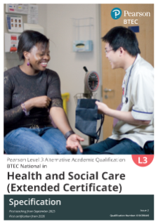

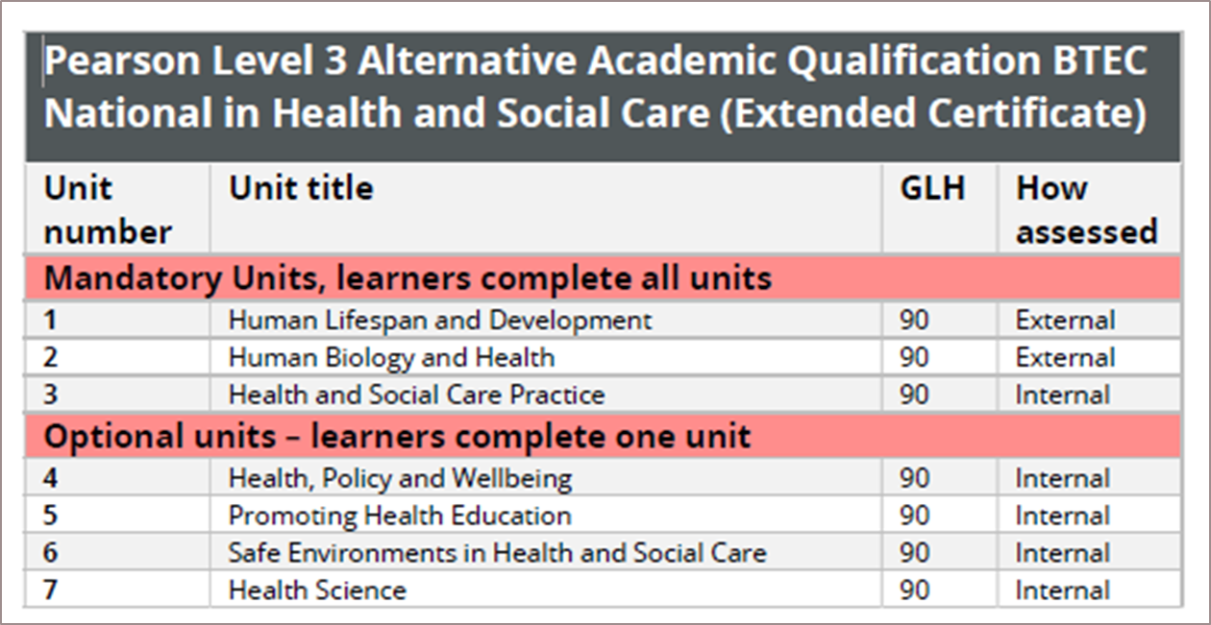

**You will also take an optional unit, Unit 6: Safe Environments in Health and Social Care, which is internally assessed.**

**Authorised textbook:**

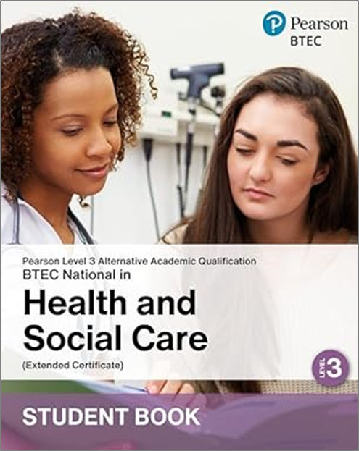 **ISBN-101292487089**