**Carshalton High School for Girls –**

Get Ready for Film Studies **April Edition – Classical Hollywood**

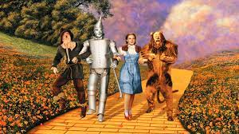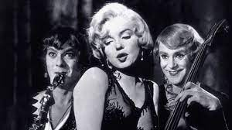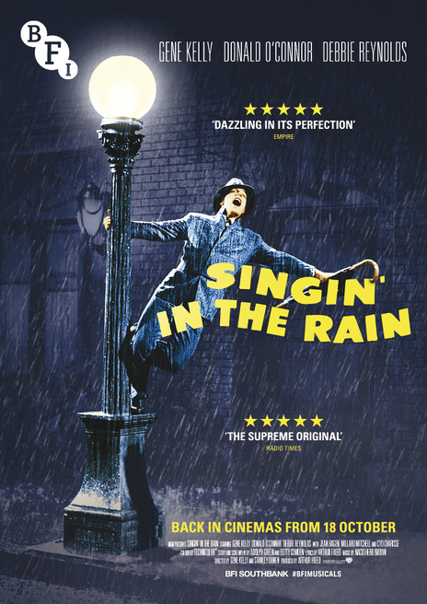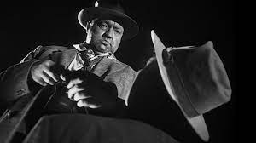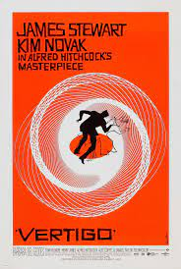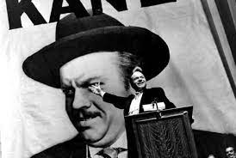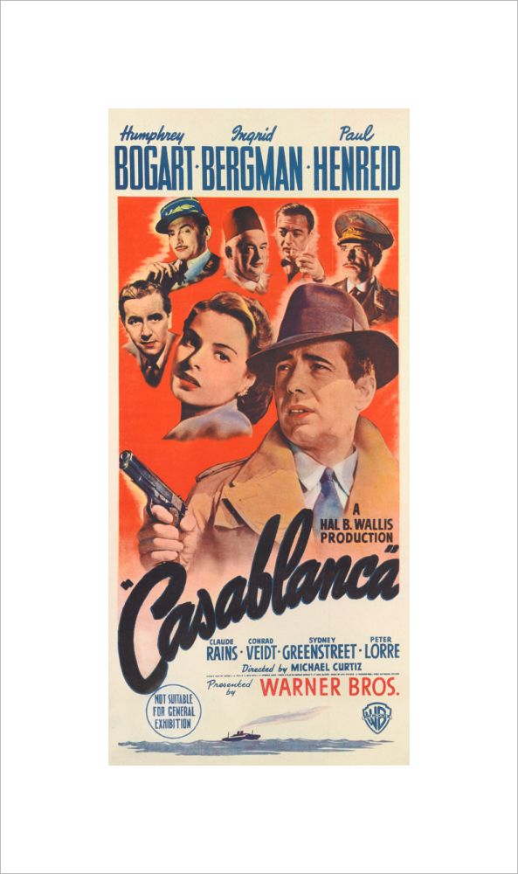

Welcome to the April edition of our Film Studies newsletter. We’re going to take a look at a very significant period of film history this month, what has become known as “classical Hollywood”, the era (between the 1930s and the 1950s) when the American film industry became dominant.

**Classical Hollywood – 1930-1960:**

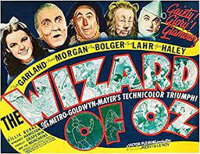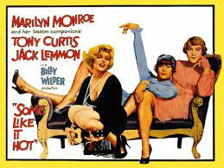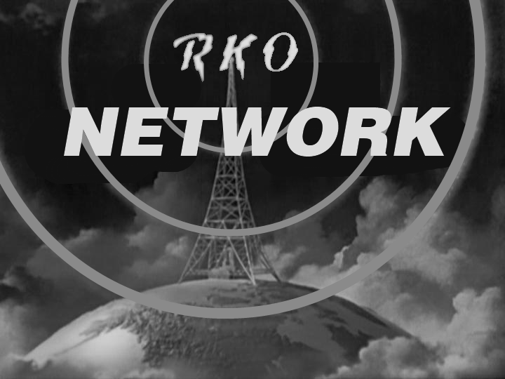 In its early history film had developed in many locations around the world but as the 20th century moved on it was the American film industry, based in Hollywood, that became dominant. By around 1930 a clear Hollywood style had developed, one that was based on realism and could create worlds audiences could believe and lose themselves in, but which also exaggerated reality, making it more exciting, romantic and dramatic than everyday life. This is an approach to filmmaking that we are all familiar with and is still with us today. By the 1930s film production had became increasingly organised and commercial, with eight studios producing the vast majority of films, The Big Five: 20th Century Fox, Metro Goldwyn Mayer, Paramount, RKO and Warner Brothers and The Little Three: Columbia, United Artists and Universal. The studio system produced films in a highly organised and efficient way that used a range of strategies to reduce the financial risk of film production and increase the chance of securing the biggest possible audiences and making a profit. Each studio had a president or head who took key decisions about when films would be released, casting and other elements of production. Directors, actors and other members of the production team tended to be contracted to studios and had little say in creative decisions, they were in effect making the studio’s film. However, many highly distinctive films were made during this period including ***The Wizard of Oz*** (1939), Michael Curtiz’s wartime drama ***Casablanca*** (1942), Stanley Donen’s musical masterpiece ***Singin’ in the Rain*** (1952) and Billy Wilder’s comedy ***Some Like it Hot*** (1959), if you haven’t seen them they come highly recommended.

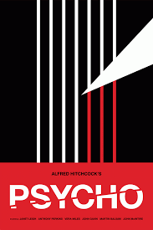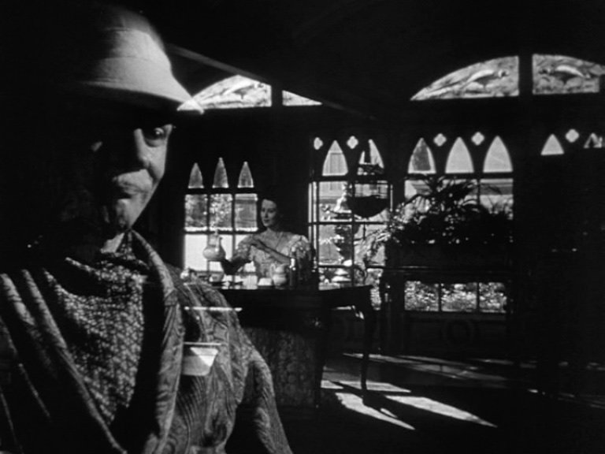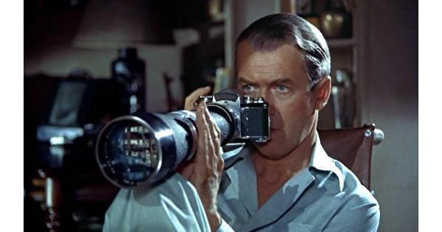 The Hollywood studios during the classical era were highly controlling, only a select few directors were able to work on projects that they had more or less full creative control over, even then they often had to work against considerable studio interference. This kind of filmmaker, one who has creative control of their own films, is known as an “auteur” (the French word for author). Perhaps the most famous auteur directors of the Classical Hollywood period were Orson Welles and Alfred Hitchcock. Both made dark, unconventional but highly original films. Hitchcock’s dark thrillers - such as ***Rear Window*** (1954), ***Vertigo***(1958), and ***Psycho*** *(*1960) - proved a box office success and he was able to work on his own projects with little interference from the studios until the end of his career. Welles had a much more difficult relationship with the studios. Following the box office flop of his first feature film ***Citizen Kane*** (1941) (now regularly voted the greatest film of all time in critics’ polls) he was heavily controlled by studios who regularly re-cut his films and even re shot sections of them. Both filmmakers have had a huge influence on filmmaking and it is very useful for you to be familiar with their work.

**Classical Hollywood Films to Watch**:

It would be useful to watch some of the following films from the Classical Hollywood era. Links are for Amazon but other platforms are available! Happy viewing:

Michael Curtiz - ***Casablanca*** (1942) <https://www.amazon.co.uk/Casablanca-Ingrid-Bergman/dp/B00I50CSCA/ref=sr_1_1?dchild=1&keywords=Casablanca+prime+video&qid=1618994149&s=instant-video&sr=1-1>

Stanley Donen - ***Singin’ in the Rain*** (1952) <https://www.amazon.co.uk/Singin-Rain-Debbie-Reynolds/dp/B00EU8VSLI/ref=sr_1_1?dchild=1&keywords=singin+in+the+rain+prime+video&qid=1618994113&s=instant-video&sr=1-1>

Billy Wilder - ***Some Like it Hot*** (1959) <https://www.amazon.co.uk/Some-Like-Hot-Marilyn-Monroe/dp/B019PB56GM/ref=sr_1_1?crid=2OCKRQVWO9CH4&dchild=1&keywords=some+like+it+hot+prime+video&qid=1618994089&s=instant-video&sprefix=some+like+it+hot%2Cinstant-video%2C137&sr=1-1>

Alfred Hitchcock – ***Rear Window*** (1954) <https://www.amazon.co.uk/Rear-Window-Thelma-Ritter/dp/B00I955CMY/ref=sr_1_1?dchild=1&keywords=Rear+window+prime+video&qid=1618994194&s=instant-video&sr=1-1>

Orson Welles – ***A Touch of Evil*** (1958) <https://www.amazon.co.uk/Touch-Evil-Orson-Welles/dp/B01CDDXY90/ref=sr_1_1?dchild=1&keywords=A+touch+of+evil+prime+video&qid=1618994222&s=instant-video&sr=1-1>

If you’re feeling adventurous you might also want to try:

Orson Welles – ***Citizen Kane*** (1941) <https://www.amazon.co.uk/Citizen-Kane-Fortunio-Bona/dp/B00H387DPW/ref=sr_1_1?dchild=1&keywords=Citizen+Kane+prime+video&qid=1618994261&s=instant-video&sr=1-1>

Alfred Hitchcock – ***Vertigo*** (1958) <https://www.amazon.co.uk/VERTIGO-Ellen/dp/B00LC8TJVK/ref=sr_1_1?dchild=1&keywords=Vertigo+prime+video&qid=1618994287&s=instant-video&sr=1-1>

**Cinema of the Month:**

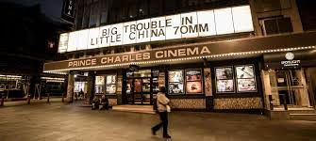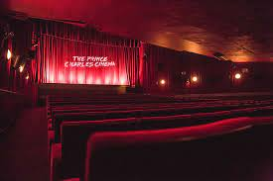 It’s a little way off yet, but cinemas are due to reopen on 17th May. In celebration of this, over the next few months we’re going to showcase a number of London cinemas or cinema chains that we think you need to know about. We’re going to start off with The Prince Charles Cinema, a London institution located on Leicester Place, just of Leicester Square in the West End. The Prince Charles is famous for its cheap tickets and shows films that have finished their runs in other cinemas and older classic films. It’s a must visit for any film lover – give it a try when you can get back to the cinema! <https://princecharlescinema.com/PrinceCharlesCinema.dll/Home>