**Teach Yourself Film**

Film as a medium is only about 125 years old and we’ve covered a lot of its history in our two years studying it. What follows is a summary of key movements (many of which we’ve studied already) and list of key films, it is something you could work your way through in preparation for university Film or Media courses. It isn’t necessarily intended as a “greatest films of all time” list (although there are some great films included), rather the films listed are significant or typical of each movement or period of film history described – I’ve also tried to stick to films we didn’t study as part of the course, there are many, many more I could have included. I hope this is of use and happy viewing!

Mr Nott.

**The Very Earliest Films (The 1890s)**

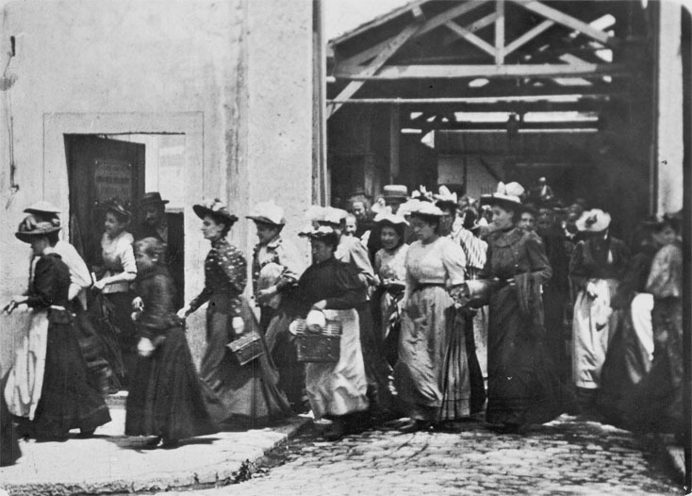

There is debate about the date of the origin of film. Photography had been around as a medium since the 1820s and throughout the 19th century there were many experiments in capturing and showing moving images. Taking advantage of the invention of roll film by American company Eastman in 1884, Frenchman Louis Le Prince produced very short moving image sequences with a camera he had invented himself. These including footage of a horsedrawn tram crossing a bridge in Leeds made in 1888. In the mid 1890s American Thomas Edison produced moving image projections lasting a matter of seconds and depicting simple events, a man sneezing, a couple kissing. However, it is brothers Auguste and Louis Lumière who are often credited with producing the first commercially successful films, shot and projected on a camera/projector they had developed themselves. The Lumière brothers screened a programme of their films in a basement room at the Grand Café in Paris in December 1895. These included single shot documentaries (or actualités – films of real events) of workers leaving the Lumière factory and a train pulling into a station. The programme also included what amounted to the world’s first narrative film, a 45 second comedy, *L’Arroseur Arrosé* (*Tables Turned on the Gardener*).

**Film to Watch:**

The Lumière Brothers – ***Workers Leaving the Lumière Factory, Lyon*** (1895): <https://www.youtube.com/watch?v=DEQeIRLxaM4>

**German Expressionism (The 1920s)**

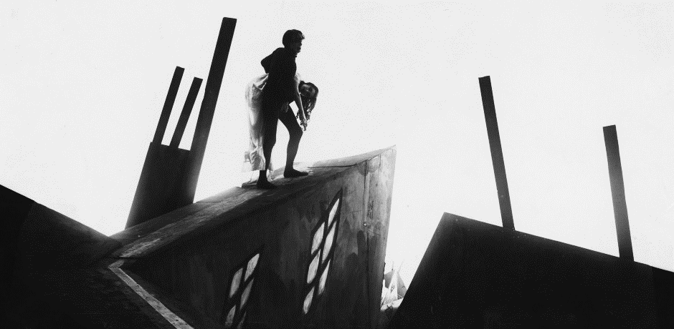

German Expressionism was one of the most significant of the modernist film movements of the silent film era. Inspired by developments in painting (there was a German Expressionist movement in art as well as filmmaking) and theatre set design in the 1910s and 1920s, German Expressionist filmmakers developed a style of filmmaking that was much less naturalistic and much more expressive, stylised and exaggerated than the “idealised realism” that was to become the style of classical Hollywood filmmaking. In German Expressionism film form was used in a more overt or exaggerated way to emphasise characters’ inner feelings or to provoke specific audience responses. Mise en scene, shot composition and high contrast lighting were often used in ways that created strong graphic images and encouraged audiences to maintain rather than suspend their sense of disbelief. Many filmmakers aligned to the German Expressionist movement ended up working in America, either through choice or because they had fled the Nazi regime in the 1930s and 1940s, with their approach having a major influence on the style and content of American films of the period.

**Film to Watch:**

Robert Wiene – ***The Cabinet of Doctor Caligari*** (1920): <https://www.youtube.com/watch?v=IAtpxqajFak>

**Soviet Montage (The 1920s)**

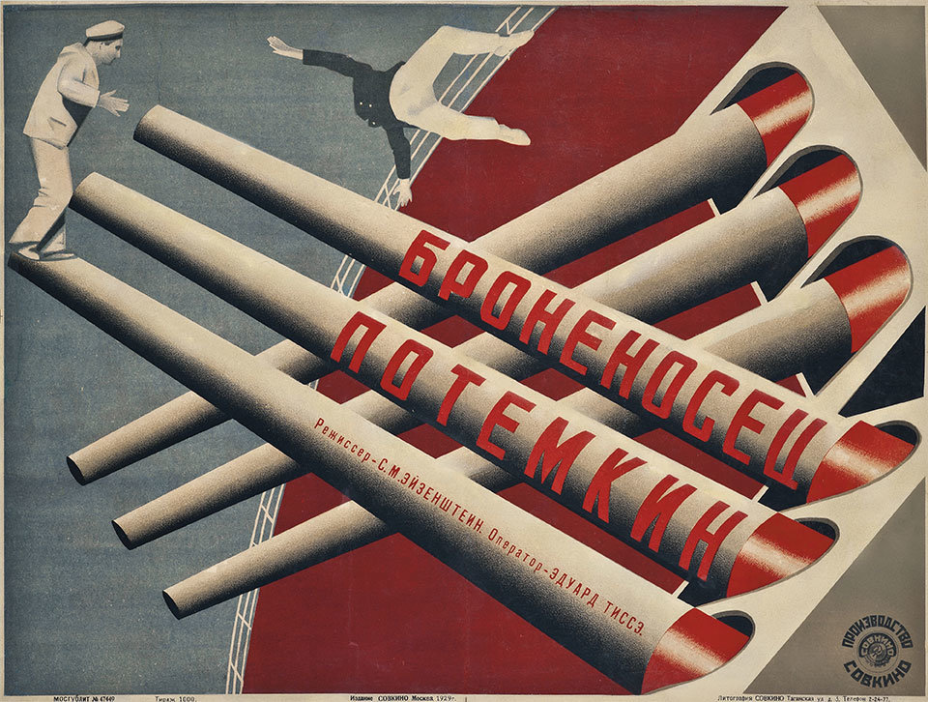

Another key film movement in the silent era is what has become known as Soviet Montage cinema. Beginning in 1917 Russia underwent a political revolution that saw the replacement of a feudalistic political system based around what was close to an absolute monarchy with a communist system of government. The revolution saw the abolition and execution of the Russian monarchy and was a period of the most profound political and social change. In the beginning at least the communist revolution opened up the possibility of a radically changed society, one where wealth, power and opportunity could be more evenly distributed and where the people could have a role in making political decisions. Russian artists were drawn into this spirit of modernist change and renewal, with exciting and innovative developments in graphic design, painting, photography and music that aimed to reform the arts in the same way that the Bolshevik revolution was reforming politics and society. Filmmaking was part of this spirit of renewal and revolution. Many Soviet films of this time are propagandist, supporting the cause of the communist revolution. However, Russian filmmakers of the period, lead by the director of the Moscow Film School, Lev Kuleshov and his most famous pupil Sergei Eisenstein, were pioneering new methods of creating meaning in film that broke away from the increasingly naturalistic and continuity based approach to narrative, editing and cinematography that were becoming conventional by the end of the 1910s. Significantly Kuleshov and Eisenstein were aware of the power of the edit as a means of emotionally guiding an audience and developed techniques that increased the expressive and emotional impact of film through using jump cuts and cross cutting to create montages of juxtaposed images. This approach can be seen most famously in two scenes in films by Eisenstein, the “Odessa Steps” scene from his 1925 film *The Battleship Potemkin*: <https://www.youtube.com/watch?v=Ps-v-kZzfec> and a scene from his 1924 film *Strike*, where footage of an attack on a crowd is intercut with footage of animal slaughter to emphasise its brutality: <https://www.youtube.com/watch?v=jWiDciPuSW4>.

**Film to Watch:**

Sergei Eisenstein – ***The Battleship Potemkin*** (1925) <https://www.youtube.com/watch?v=4mgZNobkQ2s>

**American Silent Comedy (The 1910s and 1920s)**

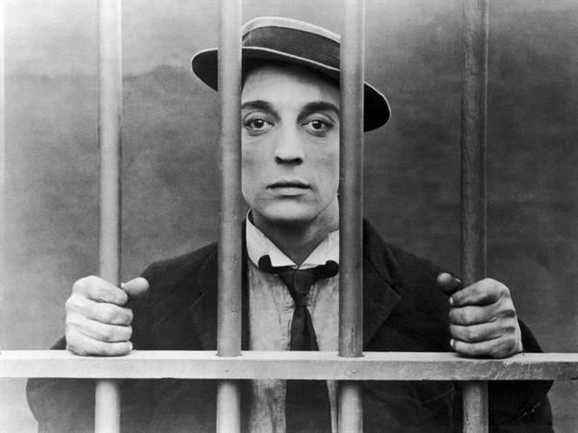

Comedy was one of the most significant genres of early cinema perhaps partly because the silence of the new medium lent itself to visual tricks and sight gags and partly because of the popularity of vaudeville theatre at the end of the 19th and beginning of the 20th centuries. Vaudeville was a type of popular theatre that combined a variety of short acts, often featuring comedy shows based around slapstick humour. Many silent comedy stars, including Charlie Chaplin and Buster Keaton came from vaudeville or music hall backgrounds. Comedies in the silent era would often be “two reelers”, short films played as part of a longer programme of films that might have also included newsreels and a longer feature film. Early comedies, such as the Keystone Kops films produced by the Keystone Studios were simple, fast paced and heavily slapstick. However, as the comedy stars of the day became established and started to gain more creative control over their own output they began to produce longer and far more sophisticated and ambitious comedy features. These included Chaplin films such as *The Kid* (1921) and *The Gold Rush* (1925), Harold Lloyd’s *Safety Last* (1923) and what is widely acknowledged as Keaton’s masterpiece, his 1926 film *The General*.

**Film to Watch**:

Buster Keaton - ***Steamboat Bill Jr.*** (1928): <https://www.youtube.com/watch?v=n9QPfiLuQ9c>

**Other Important Silent Films (The 1920s)**

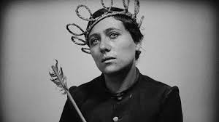

As the “rules” of filmmaking hadn’t been determined and as film hadn’t yet become fully industrialised and commercialised arguably the silent era was a period of unparalleled creative freedom, ambition, innovation and experimentation.   Many of the films made in this period took a very different stylistic approach to that we’re familiar with today – filmmakers were genuinely experimenting with different ways of structuring narrative and developing a visual language with which to create meaning. In 1927 for example the Danish filmmaker Carl Theodor Dreyer used transcripts from the trial of Joan of Arc in 1431 to create a film that combined highly expressive cinematography and editing, particularly the use of intense close ups, with extreme realism of performance to depict Joan’s trial, torture and execution. French filmmaker Abel Gance made pioneering use of a bewildering range of technical innovations in his hugely ambitious 1928 film *Napoleon* about the life of the early 19th century French emperor. These included, amongst other things, shooting in a widescreen format, filming using multiple cameras, using handheld camera work and other forms of innovative camera movement and using double exposures, split screens and coloured film tinting. German Expressionist filmmaker FW Murnau, who had made *Nosferatu*, moved from Germany to America where he was given unlimited funds and complete creative freedom by William Fox to make what amounted to an American German Expressionist film, *Sunrise*. The film, which made use of exaggerated, expressionist sets, double exposures, extreme perspectives and extended cross dissolves amongst other techniques is often voted amongst the greatest films of all time in critics’ polls. The following articles, one proclaiming the 1920s as the greatest ever film decade and the other outlining significant films from the silent era are an interesting read: <https://www.theguardian.com/film/filmblog/2018/apr/04/my-favourite-film-decade-1920s-nosferatu-the-general> <https://www.theguardian.com/film/filmblog/2013/nov/22/top-10-silent-movies-films>

**Film to Watch**:

FW Murnau – ***Sunrise*** (1928): <https://www.youtube.com/watch?v=y8Vjxw6cL7g>

**Classic Hollywood/Classical Hollywood (1930-1960)**

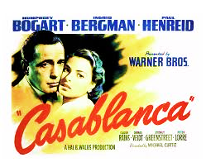

By 1930 film as a medium was nearly 40 years old and many of its conventions were becoming established. In its early history film had developed in many locations around the world but as the 20th century progressed it was the American film industry that became dominant. A distinct Hollywood style had developed, defined by a set of conventions that created a sense of exaggerated or idealised realism, arguably a style of cinema that is with us today and a style that we are all familiar with. By the 1930s film production had became increasingly industrialised, with eight studios producing the vast majority of films. The Big Five: **20th Century Fox**, **Metro Goldwyn Mayer**, **Paramount**, **RKO** and **Warner Brothers** were vertically integrated – meaning that they produced and distributed films and owned chains of cinemas that exhibited them. The Little Three: **Columbia**, **United Artists** and **Universal** produced and distributed films but did not own cinemas. The studio system produced films in a highly organised and efficient way that used a range of strategies to reduce the financial risk of film production and maximise the chance of securing the biggest possible audiences and making a profit. Each studio had a president or head who took key decisions about scheduling, casting and other elements of production. Directors, actors and other members of the production team tended to be contracted to studios and had little say in creative decisions, they were in effect making the studio’s film.

**Film to Watch**:

Michael Curtiz - ***Casablanca*** (1942)

Only a select few directors were able to operate as “auteurs” and work on projects that were their own creative visions, although they often had to work against considerable studio interference (as was famously the case with Orson Welles) to do so. There are a number of significant films produced in this way during the classic or classical period, two of them are:

**Films to Watch**:

Orson Welles – ***A Touch of Evil*** (1958)

Alfred Hitchcock – ***Vertigo*** (1958)

**Film Noir (1940s and 1950s)**

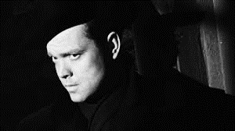

Film noir is a body of unconventional crime films released in the 1940s and 1950s and made in a style that was largely at odds with the classical Hollywood style. Most original noirs were made by the American film industry although some key films were made outside of it. Film noir is a term that wasn’t used by the film industry or those who made the films at the time they were made, rather it was applied by French film critics in the 1940s (film noir is a French term that translates as black film or dark film). Famous film noirs include ***The Maltese Falcon*** 1941, ***Double Indemnity*** 1944, ***The Big Sleep*** 1946, ***The Killers*** 1946, ***Out of the Past*** 1947, ***The Third Man*** 1949***, Night and the City*** 1950, ***The Asphalt Jungle*** 1950, ***Sunset Boulevard*** 1950***, The Big Heat*** 1953, ***The Killing*** 1956***, A Touch of Evil*** 1958 – you should try to watch as many of these films as you can. Noirs were produced by the major studios on relatively low budgets largely as B movies, films that would have shown early in the programme in the cinema before the main feature at a time when many people would have gone to the cinema for an entire morning, afternoon or evening and watched several films in succession. It could be argued that because of this the directors of noirs had the freedom to make films that dealt with grittier subject matter and were more unconventional and experimental than Hollywood’s more mainstream “A list” films. A substantial number of noirs were also directed by European directors, many of whom had fled Nazi persecution or occupation for America in the 1930s and 1940s and brought with them a different and perhaps more experimental approach to both the technical aspects of filmmaking and ways of structuring narrative than was common in the American film industry at the time (more on this later). However, noirs weren’t particularly popular with American audiences, being seen as unpatriotic, too experimental and overly pessimistic. In many cases they also pushed at the limits or even broke the Hays Code (the set of regulations that determined what could and could not be shown in films, forbidding films from showing things like a character getting away with murder or unmarried people in bed with each other). As a result, and as is the case with *The Lady from Shanghai*, some noirs were re-edited by the studios against the wishes of their directors to make them more palatable to a mass audience. When imports of American films to continental European countries started again in the mid 1940s the dark, pessimistic tone of film noir was much more popular there, with populations recovering from the destruction of the Second World War.

**Film to Watch:** Robert Siodmak - ***The Killers*** (1946): <https://player.bfi.org.uk/rentals/film/watch-the-killers-1946-online>

**Italian Neo Realism (1940s)**

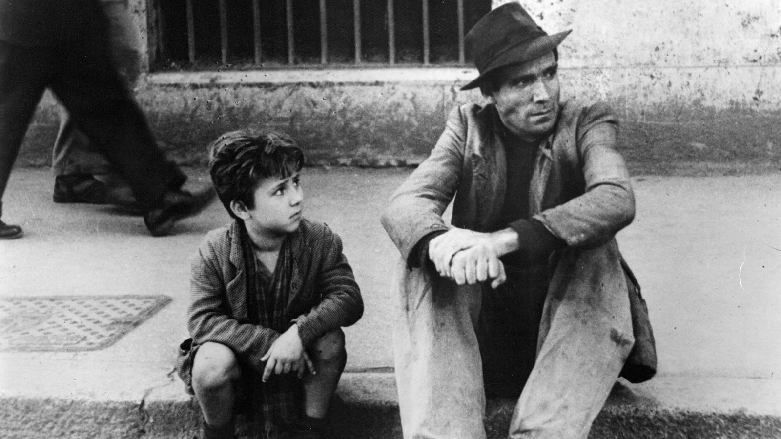

Neo means new, so when we talk about Neo-Realism we are talking about a “new realism”, a film movement which originated in Italy immediately after the Second World War. Influenced by experiments with realism before the war (particularly the work of the French director Jean Renoir – see his 1935 film *Toni* - <https://www.youtube.com/watch?v=RvMyEZnSuyU> ) filmmakers of the Italian Neo-Realist movement made films on low budgets and with limited resources, they wanted to produce films that represented the lives of ordinary, working people emerging from the chaos of war and life under a fascist dictatorship as realistically as possible. To achieve this they prioritised shooting on location, often in working class neighbourhoods, using naturalistic lighting and a fluid shooting style based around wide and mid shots. The Neo-Realists frequently cast untrained or non professional actors and encouraged a natural style of performance. They also insisted on high levels of realism in other elements of mise en scene, often using real objects and items of clothing as props and costume. Their approach to narrative was also revolutionary, rejecting the cause and effect narrative structures of classical Hollywood which were based on conflict that would be resolved by the end of the film. Instead the Neo-Realists favoured a less dramatic and more realistic and inconclusive approach to narrative, where events unfold slowly and where minor events (eating dinner, completing household chores etc.) were given equal screen time and status to events that were more central to the plot. Italian Neo-Realism had a huge influence, particularly on films made in the developing world but also on film movements such as the French New Wave, New Hollywood and the British social realist film movement of the 1960s.

**Film to Watch:** Vitorio De Sica **- *The Bicycle Thieves*** (1948):

<https://www.youtube.com/watch?v=_yHGZ2RK500>

**World Film (1950s-1970s)**

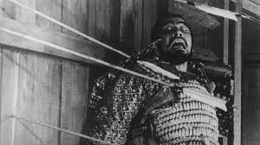

The end of the colonial era that followed the Second World War lead to a growing sense of national assertiveness as former colonies gained their independence, an attitude that was increasingly reflected in the filmmaking of these countries. Hollywood had frequently represented developing or colonised countries and their people as either exotic, tragic or threatening but from the1950s onwards filmmakers from developing or previously colonised countries began making films that challenged these stereotypes and consciously pushed against Hollywood’s style and values. These filmmakers sought to create a new kind of self determined national cinema, one that represented their countries from within, creating films shot from the perspective of ordinary people and more directly showing the reality of their lives and experiences. Many of them were influenced by film movements such as Italian neo-realism of the1940s or the new waves of European cinema of the 1950s and aided by technological developments such as the availability of more portable camera and sound recording equipment and faster film stock that made it possible to shoot on location with a small crew and therefore cheaper and easier to make films. This period saw a flowering of filmmaking in developing countries as diverse as India, The Philippines, Senegal, Egypt, Iran, Ethiopia and Cuba.

In Japan the film industry was resurgent following the Second World War and produced a string of distinctive, highly original films, quite different to those produced by the mainstream American film industry.

**Films to Watch:**

Satyajit Ray – ***Pather Panchali*** (1955): <https://www.dailymotion.com/video/x6j4i9n>

Akira Kurosawa – ***Throne of Blood*** (1957)

**French New Wave (1950s and 1960s)**

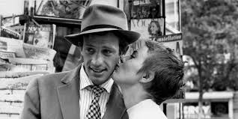  
 In the 1950s and 1960s, film in Europe was undergoing a transformation. Leading the way was a French film movement that became known as the French New Wave. The filmmakers of the French New Wave had taken advantage of technological developments at the end of the 1950s (lighter cameras and sound recording equipment, developments in film stock) that made it possible to shoot cheaply and easily on location, with natural light and small crews to develop a form of cinema that challenged the conventions of the established French film industry of the day. This style of filmmaking, known as “cinéma de qualité” (cinema of quality) which the directors of the French New Wave dismissed as “cinéma du papa” (dad’s or grandad’s cinema), largely focused on the production of unchallenging big budget studio shot films, often adapted from historical literary texts and made with very large crews . The directors of the French New Wave were cinema enthusiasts or cinephiles, who had grown up on the influx of American movies into Europe after the Second World War and were passionate advocates of directors from film history who had been able to produce original work and had a distinct creative style. Many directors of the French New Wave, including two of its most famous, Francois Truffaut and Jean Luc Goddard, explored ideas about film through writing articles for the influential magazine *Cahiers du Cinéma.* France, at the time of the French New Wave was undergoing similar social and demographic changes to other western countries and the directors of the new wave wanted to create a style of cinema and approach to narrative and mise en scene that was contemporary and relevant to the lives of the people who would watch their films. They also wanted to explore totally new ways of shooting and editing film, ways that celebrated film’s uniqueness as a medium and drew attention to its production processes rather than trying to hide them. Their films were hugely popular with young audiences and ultimately a major influence on a new generation of young Hollywood directors in the 1960s and 1970s.

**Films to Watch:**

Jean Luc Godard - ***Breathless*** (1960)

*François Truffaut -* ***400 Blows*** (1958)

**British Social Realism (1950s and 1960s)**

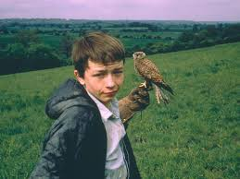

Social Realism was a British film movement, influenced by Italian Neo Realism and elements of the French New Wave that emerged in the1950s and 1960s. As with Neo Realism and the French New Wave, there was an emphasis on location shooting and a mobile shooting technique, the casting of unknown or non professional actors, the use of contemporary settings and narratives, a focus on “ordinary” characters from working class or lower middle class backgrounds and often young, high levels of realism in mise-en-scene, lighting and performance and an often improvised or partly improvised approach to dialogue. The key difference between British Social Realist films and the films of the Italian Neo Realists and the French New Wave is that many of them explicitly sought to address social issues or actively bring about social change. Key British Social Realist films include: *Room at the Top* (1958); *Saturday Night and Sunday Morning* (1960); *A Taste of Honey* (1961); *The Loneliness of the Long Distance Runner* (1962); *A Kind of Loving* (1962); *This Sporting Life* (1963); *Kes* (1969). Many British directors, perhaps most notably Mike Leigh and Ken Loach have continued to work in a way influenced by this approach to the present day. Loach’s work in particular is characterised by an overtly political approach and an attempt to use filmmaking to bring about social change, indeed his1966 television film, *Cathy Come Home* (<https://www.youtube.com/watch?v=xky8ZqhNAlo>), about a young mother repeatedly evicted from rented accommodation, lead to the establishment of the homeless charity Shelter.

**Film to Watch:**

Ken Loach - ***Kes*** (1969)

**New Hollywood (1960s and 1970s)**

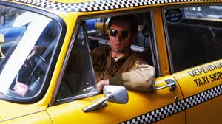

With audiences declining and financial problems mounting by the late 1960s, the studios had to find a way to reinvent themselves and make the films that would engage the crucial youth audience, which was an increasingly significant target for the film industry. The studios had witnessed (and largely ignored) a series of revolutions in European filmmaking from the mid 1940s onwards and the fifties and earlier sixties work of pioneering independent American producers and directors (such as Nicholas Ray, Elia Kazan, John Cassavetes, Sam Peckinpah, Sydney Lumet and Stanley Kubrick) who wanted to incorporate these new approaches to filmmaking into their own productions. The studios considered them too unusual and experimental to be appealing to American audiences. However, the box office success of a trio of American films made in the unconventional style of the European “new waves”: *The Graduate* (1967); *Bonnie and Clyde* (1967) and *Easy Rider* (1969), made them take notice. All three films had been producer/director lead and made on low budgets, all three had been surprisingly successful at the box office – bringing in income of around 10 times their production costs. They demonstrated to the studios that there was an appetite amongst audiences (particularly the all important youth audience) for a more experimental approach to narrative, editing and cinematography and that a new breed of young writers, producers and directors, left to work without interference from the studios, could produce material that would unlock the studios’ access to the youth market. These three films effectively shifted the film industry away from a distribution lead approach to filmmaking and towards a production lead model and ushered in a period, lasting from about 1970 to 1980, of unprecedented levels of funding and creative freedom for filmmakers and the creation of a string of films that are considered classics today.

**Film to Watch:**

Martin Scorsese – ***Taxi Driver*** (1976)

**Contemporary American Independent Film (1990-Present)**

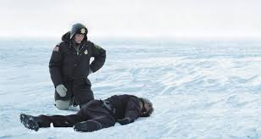During the late 1980s and early 1990s independent production companies began to show that they were able to produce films on low budgets that could be very financially successful at the box office – the kinds of projects the mainstream American studios were unwilling to back at the time. The most significant of these companies was Miramax, set up by brothers Bob and Harvey Weinstein in 1979. It had a succession of box office hits with films such as *Sex, Lies and Videotape* (1989), *Reservoir Dogs* (1992), *Clerks* (1994), and *Pulp Fiction* (1994) and many of the films it produced and distributed were nominated for academy awards. The success of Miramax arguably created conditions that made it easier for independent filmmakers to secure funding and distribution deals for their films, it also interested the major film studios who saw that low budget independent productions had the potential to make a significant profit and bring the prestige associated with awards or award nominations. As a result, during the 1990s many of the major studios set up (or bought) their own speciality or independent divisions that specialised in making lower budget production lead films which gave their directors creative freedom with little or no studio interference.

**Film to Watch:**

The Coen Brothers – ***Fargo*** (1996)

**Contemporary European Film (1990 – Present)**

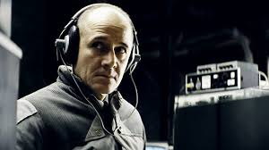

Many of film’s earliest innovations were European, and in the first decade or so of the film industry many of the most powerful and significant film studios and production companies were European. Gradually the balance of power began to shift to a point where, by the mid 1910s, film became an industry dominated by American companies, something that has persisted to the present day. As with the contemporary British film industry, in comparison to the studio dominated approach of America the contemporary European film industry is smaller in scale and largely production lead.  
 It’s hard to get figures that demonstrate the size of the European film industry as a whole, although we can find them for individual European countries. For example, compared to the American film industry which generated approximately $25 billion in revenue in 2018, the French and German film industries generated approximately £3 billion of revenue each in the same year with the Italian and Spanish industries generating approximately £1 billion apiece. As with the British film industry, the film industries of European countries tend to be structured in very different way to the mainstream, vertically integrated American film industry. Rather than being distribution lead and commercially driven they tend to be largely production lead, with filmmakers or production companies developing productions *before* securing finance or distribution deals and having to source funding from a range of providers to put their films into production. There are many European companies and organisations that provide funding to European filmmakers, perhaps most notably the EU organisation Creative Europe which, through its media programme has a role similar to the BFI in the UK in funding filmmakers. While we need to be careful about making simplistic generalisations about the nature of films produced by different national film industries it could be argued that the smaller scale and production lead and less commercially driven nature of the European film industry allows some filmmakers opportunities to work in more experimental or unconventional ways, something that is certainly the case with *Pan’s Labyrinth*.

**Film to Watch:**

Florian Henckel von Donnersmarck – ***The Lives of Others*** (2006)

**Documentary Film (1895-Present)**

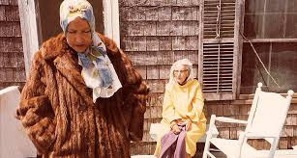

Documentaries have had a place in film history since the beginning of the medium at the turn of the Twentieth Century. Indeed, although the term hadn’t been coined at the time that they were made, some of the earliest films ever made could be classified as forms of documentary. Since then documentary has evolved as a form of filmmaking, developing a range of conventions and characteristics and being especially affected by and responsive to technological change.

**Films to Watch:**

Robert Flaherty - ***Nanook of the North***(1922): <https://www.youtube.com/watch?v=3F0G3IZA6OI>

Dziga Vertov - ***Man with a Movie Camera***(1929): <https://www.youtube.com/watch?v=cGYZ5847FiI>

Harry Watt and Basil Wright - ***Night Mail***(1936): <https://www.youtube.com/watch?v=e_4r_YymgSI&safe=active>

Albert and David Maysles - ***Grey Gardens***(1975): <https://www.youtube.com/watch?v=5HNhlry-ggg&list=PLKHCtZGOtY8ekZgou0-_vzdjgWSYXtM7a&safe=active>

Jean Rouch and Edgar Morin - ***Chronique d’un Eté***(1961): <https://www.youtube.com/watch?v=Pxk-fg771r8>

Errol Morris – ***The Thin Blue Line***(1988): <https://www.youtube.com/watch?v=tjSrTUkqKbA>

Steve James - ***Hoop Dreams*** (1994): <https://www.youtube.com/watch?v=scFTAyjs2cc>

Patricio Guzmán – ***Nostalgia for the Light*** (2010): <https://www.youtube.com/watch?v=j6VDlxFYmKg>

Joshua Oppenheimer *–* ***The Act of Killing***(2012): <https://www.youtube.com/watch?v=SD5oMxbMcHM>